

Server 3.0

Manual
1 June 2010

This is the manual for version 3.0 of the MetaTexis Server, a TM and terminology server
running in Windows®.

Copyright: Hermann Bruns 2007-2010

MetaTexis Software and Services
Am Gottbach 32
54296 Trier

Web site: www.metatexis.com

Email: support@metatexis.com

Trademarks

MetaTexis and the MetaTexis Logo are trademarks.
All other trademarks used herein are the properties of their respective owners.

Contents
What's new 1
Trial Version 1
New Functions 1
Features Planned 1
Acknowledgements 2
Warranty Disclaimers and Liability Limitations 3
Introduction 4
What is the MetaTexis Server? 4
Versions 5
Features (overview) 5
Installation 7
Requirements 7
Installation 7
Uninstalling 8
Quick Start 9
Just Go Ahead 9
Help 9
Concepts and Functions 10
Basics 10
Communication between client and server 10
Main screen 11
About MetaTexis Server 12
Entering the license key 13
Server monitor 13
Clients, users and database profiles 15
Maintaining clients 16
Users 18
Database profiles 23
Remote administration 30
Client options 31
Program options 32
Maintaining TMs and TDBs 38
Displaying TMs 42
Displaying TDBs 46
Importing and Exporting TMs and TDBs 51
Compressing TMs and TDBs 65
Annex 67
Connecting a client to the server 67
Edit user data 69
Import/Export Condition Language 71
Syntax 71
Localization 74
Managing Language Files 74
Edit Language Files 75
FAQ 81
General note 81
Database engines 81

What's new

Trial Version
To run the MetaTexis Server, you need a license key. If you would like to test MetaTexis, please send a request to support@metatexis.com.

New Functions
Version 3.0
- Client-enabled
- Remote administration
- Additional database engines
- Better performance
- Better stability

Features Planned
Version 4 (2011):
- Support for server clusters
- Project management

Acknowledgements
All my gratitude goes to my wife and my children. Of course, they were affected most by the MetaTexis project. In fact, when I initially launched the project in summer 2000 I did not anticipate how much effort and time is needed to program a decent CAT tool. Too often, I was so completely absorbed by the programming problems that I neglected my family.
Therefore, I dedicate MetaTexis to Ina, Jule and Gedeon.

Hermann Bruns

Warranty Disclaimers and
Liability Limitations
The MetaTexis software, and all accompanying files, data and materials, are distributed "AS IS" and with no warranties of any kind, whether express or implied. Good data processing procedure dictates that any program be thoroughly tested with non-critical data before relying on it. The user must assume the entire risk of using the program.
Any liability of MetaTexis Software and Services will be limited exclusively to refund of the purchase price, if any. In addition, in no event shall MetaTexis Software and Services, or its principals, shareholders, officers, employees, affiliates, contractors, subsidiaries, or parent organizations, be liable for any incidental, consequential, or punitive damages whatsoever relating to the use of MetaTexis, or to your relationship with MetaTexis Software and Services.
In addition, in no event does MetaTexis Software and Services authorize you to use MetaTexis in applications or systems where MetaTexis' failure to perform can reasonably be expected to result in a significant physical injury, or in loss of life. Any such use by you is entirely at your own risk, and you agree to hold MetaTexis Software and Services harmless from any claims or losses relating to such unauthorized use.

Introduction

What is the MetaTexis Server?
The MetaTexis Server allows two or more translators to use the same translation memories (TMs) and the same terminology databases (TDBs) for their translations. To put it more technically: The MetaTexis Server is a server program that provides access to centrally stored TMs and TDBs for client programs that are run on computers connected to the server via LAN or Internet. This allows a group of translators to work with the same translation memories and terminology databases which has several advantages:
- Increased efficiency: The translation results of one translator are immediately available for all other users of the same databases. Each translator can benefit from the work of another translator of the team without extra manual actions (that is, there is no need to export data, to exchange files, and to import data).
- Increased consistency: The danger of inconsistencies in the produced translations is minimized. Especially in the case of terminology databases it is important to use the same terminology for a given project.
- Increased security: Especially in the case of confidential data it is important to avoid sending out too much data at a time. By using a central server, each translator has access to a huge database, but does only retrieve one bit of information at a time. This way, the risk of data misuse is minimized. Moreover, the data sent via LAN/Internet by the MetaTexis server are encoded and can not easily be read by spy programs.
Currently, the following client programs have an interface for the MetaTexis Server: MetaTexis for Word NET/Office, Metatexis Scout, MetaTexis Database Editor, MetaTexis Server Remote Administrator. As a translator, if you want to use the services provided by the MetaTexis Server, you need to run MetaTexis for Word on your computer. Users, who just need search functions, can use the MetaTexis Scout, while users who only need to view or edit TMs and TDBs can use the MetaTexis Database Editor. If you are a project manager who needs to administer users and databases on a Server, you will use the MetaTexis Server Remote Admin program.
An example: If 7 translators work on a project, each translator will run MetaTexis for Word NET/Office on his computer, while the MetaTexis Server runs on one computer that can be accessed by the 7 client computers via LAN or Internet. The project manager will additionally run MetaTexis Server Remote Admin, while the customer might be given access to the TMs and TDBs via the MetaTexis Scout.

Versions
There are three versions of the MetaTexis Server: Team, Office, and Enterprise:
The Team version provides access for a maximum of 3 users only, and it does not allow Internet connections (only LAN connections possible). The advanced features of the Enterprise version are not available.
Compared to the Enterprise version, the Office version only allows up to 10 users. The advanced features of the Enterprise version are not available.
The Enterprise version is only limited by the license key purchased. The following features are only available in this version: WWW server, client administration, remote administration, dynamic licensing (optional).

Features (overview)
Easy installation: The MetaTexis Server can be installed in less than a minute.
Easy setup: To setup the MetaTexis Server for a group of translators just takes a few minutes.
User-friendly: Start to become a server administrator without studying manuals. Many TM and TDB related functions are identical with the related functions in MetaTexis for Word.
Server: Runs and maintains TMs and TDBs on a central server
Client enabled: The Enterprise version allows you to run different clients with database profiles and users.
Remote administration: The Enterprise version allows complete remote administration for each client (via the program "MetaTexis Server Remote Administration"). This means, the client administrators do not have to have direct access to the computer where the Server is running.
Extendable: The number of users and databases is only restricted by license and hardware capacities.
Database engines: Can use different professional database engines (MS SQL Server, MySQL, PostGreSQL, SQLite, MS Access)
WWW server: The Enterprise version includes a simple WWW server that allows the user to provide information via WWW without having to install a full WWW server.
Dynamic licenses: The Enterprise version allows administering dynamic licenses for MetaTexis for Word. If the translators do not need a Metatexis for Word as a standalone program, dynamic licenses can be provided to each translator via the MetaTexis Server. Each client will have to access the Server at least once per day to renew the dynamic license. When the dynamic license has expired, or when the user has no access to the Metatexis Server, the functions in MetaTexis for Word will be restricted to the functions of the free version.
Fast and efficient support by the developers.

Installation

Requirements
Before you install the MetaTexis Server make sure that the minimum requirements are met:
- Operating system: Windows Server, Windows 2000®, Windows XP®, Windows Vista®
- Microsoft .NET Framework 3.5
- Microsoft Access 2007 Runtime OR Microsoft Access
- Reliable connection to the local area network (LAN) and/or to the Internet

Installation
The MetaTexis Server can be purchased at www.metatexis.com. Installing is very easy: You only need to run the installation program “MetaTexisServerV3.exe”.
To install MetaTexis, execute the following step:
- Make sure that the Microsoft .NET Framework 3.5 is installed. Without this the MetaTexis Server will not run. The .NET Framework 3.5 is available for free via this link:
http://www.microsoft.com/downloads/details.aspx?familyid=333325fd-ae52-4e35-b531-508d977d32a6
- Make sure that either Microsoft Access or Microsoft Access 2007 Runtime is installed. The Microsoft Access 2007 Runtime is available for free via this link:
http://www.microsoft.com/downloads/details.aspx?FamilyID=d9ae78d9-9dc6-4b38-9fa6-2c745a175aed
- Execute the installation file MetaTexisServerV3.exe. Follow the instructions given by the installation program.
- After the installation has finished, the MetaTexis Server will be launched automatically. If this is not so, launch the Server manually.
- If you have purchased a license key, click the About this program button. In the dialog box shown click Enter license key and enter the license key. (Please note: The license name is case sensitive and must be entered in exactly the same way it was provided to you. It is recommended to copy and paste it.)
- Configure your firewall to allow requests from the MetaTexis client programs and answers by the MetaTexis Server on the ports defined.
If the MetaTexis Server does not run smoothly, or if you encounter any other problems read the MetaTexis FAQ. If this does not help, contact the MetaTexis support at support@metatexis.com.

Uninstalling
You can uninstall MetaTexis in the same way as any other Windows program.
There are two ways to uninstall MetaTexis:
(a) via the Programs menu:
- Display the MetaTexis sub-menu in the Programs menu of Windows
- Click Uninstall MetaTexis Server and confirm when you are prompted if you really want to uninstall the program.
(b) via the Control Panel:
- On the Windows desktop (or in the start menu) click My computer
- Click Control panel.
- Click Add or remove program (or Software). A dialog box with a list of all programs installed on your system will be shown.
- Look for MetaTexis Server 3.x, and click it.
- Confirm when you are prompted if you really want to uninstall the program.

Quick Start

Just Go Ahead
After having finished the installation you only need to execute a few steps to run the server:
- Activate the tab Users and database profiles, activate the sub-tab Users and add a user by clicking the button Add. In the dialog define a user ID. The default password is "initial". To change the password, click Password (this is optional). Click OK to save the new user.
- Activate the sub-tab Database profiles and create a database profile by clicking the Add button. In the dialog shown define a name for the database profile, create a translation memory and a terminology database. Assign the user created in step 1 to this database profile by clicking the appropriate Add button, and select the user. Click OK to save the new database profile.
- Activate the Options tab and have a look at the lower right frame where you find a list box with one or more IP addresses.
- Send the server address (IP address), the server port (default: "5001"), the name of the client (default: "Client1"), and the logon data (user ID and password) to the user. The user can use these data to connect to the Server. The manuals for the client programs contain a special section on how to connect to the server. General instructions can be found in the annex of this manual.

Help
The MetaTexis Server includes a comprehensive online help system with context sensitive help for each dialog box. The online help has exactly the same content as the manual.
To access the context sensitive help for a dialog, click the Help button at the lower left corner of each MetaTexis dialog box, or press F1 on the keyboard.

Concepts and Functions

Basics
The MetaTexis Server provides a defined group of users with access to centrally stored translation memories (TMs) and terminology databases (TDBs). For this reason, the administrator of the MetaTexis Server has to maintain the users who are supposed to work with the database, and to assign TMs and TDBs to the users.
TMs and TDBs are not assigned to users directly, but through database profiles. In other words, the assignment between users and database is achieved through database profiles. A database profiles is a collection of references to TMs and TDBs and some further settings that steer the database usage.
As a translation project manager you would use a database profile to define the TMs and TDBs needed for a translation project. All translators who are supposed to take part in the translation project must be defined as user and assigned to the database profile.
So, the main job of a MetaTexis Server administrator is to define users and database profiles and to assign users to database profiles (or database profiles to users, both having the same result).
Version Enterprise of the MetaTexis Server allows defining different clients. For each client different remote administrators, as well as different users, database profiles and further database options can be defined. Clients can be run completely separately. This way you can make sure that one group of users and database profiles does not interfere with another one. In other words, you would only define different clients when you need to administer completely separate translation departments, for example.

Communication between client and server
The users can access the MetaTexis Server via a local area network (LAN, usually a network inside an organization), or via Internet. The technology for connections is TCP/IP.
The MetaTexis Server only accepts requests by valid users for valid database profiles. When a client program like MetaTexis for Word tries to access a database profile, it sends a TCP/IP message to the server which checks if the user and database profile data are valid and active. If this is the case, the TMs and TDBs are processed according to the request type, and the results are returned. All requests are handled in separate tasks. If two or more requests are sent at the same, the tasks are processed at the same time in parallel.
Note: If a firewall is running on the server computer (or if the whole LAN is protected by a firewall and the MetaTexis Server is supposed to accept Internet connections) the server administrator must make sure that the firewall is configured in a way to allow incoming requests from client programs and outgoing answers by the MetaTexis Server on the ports defined.

Main screen
The main dialog of the MetaTexis Server looks as follows:
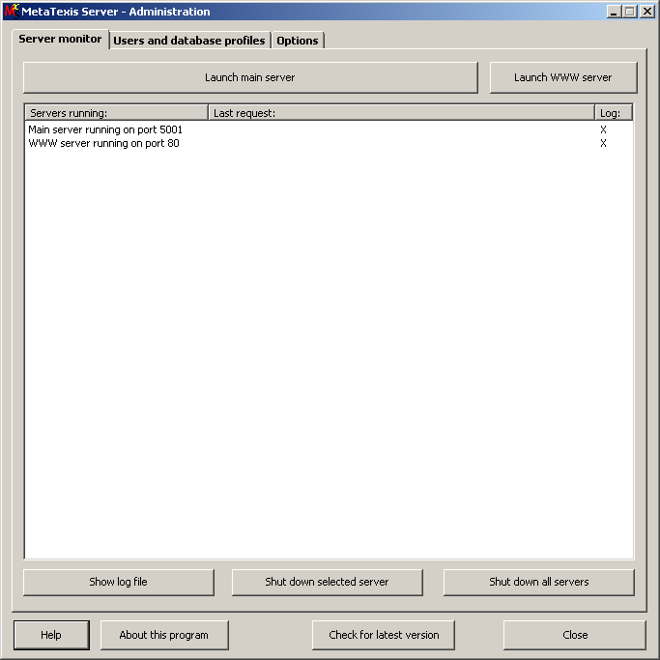
The main program dialog consists of 3 main tabs that allows you to monitor and administer the Server. At the lower margin there are four buttons which are explained in detail below:
- Help:
Click this button to get help for the MetaTexis Server. According to the main tab(s) selected the related help text will be shown.
- About this program:
When you click this button the About dialog is displayed. For more details, see below.
- Check for latest version:
When you click this button, the MetaTexis Server will contact the MetaTexis homepage to check if any updates are available.
- Close:
Click this button to shutdown all servers and to quit the MetaTexis Server. Before this actually happens, you will be prompted.

About MetaTexis Server
When you click the About this program button the following dialog box will be displayed:
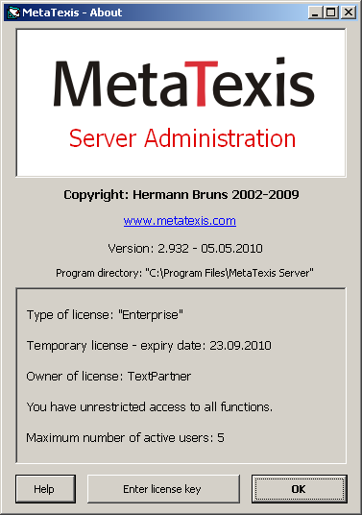
This dialog box informs you about:
- Copyright
- MetaTexis Version, including version number and release date
- Program directory
- License information (type of license, owner of license, information about any usage restrictions)

Entering the license key
When you click the button Enter license key in the About dialog box, the following dialog box will be shown:
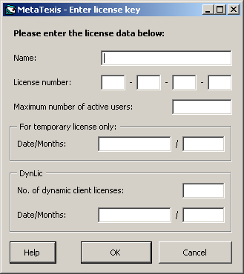
Here you can enter the license data. You need to enter the license key data exactly as provided, including the name! The name is case sensitive!
To finish and save, click on OK. You will then be informed whether you have entered a correct license key.

Server monitor
The Server monitor tab lists all servers currently running. By default, the main server starts at program start-up. A typical situation is displayed here:
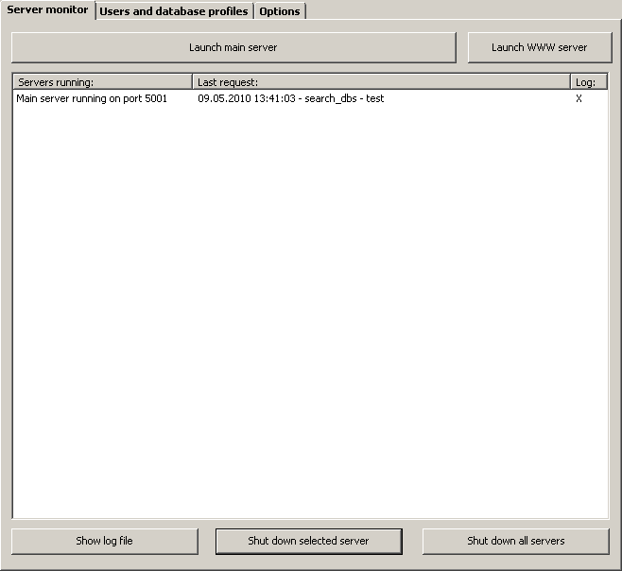
The main element is the list of servers currently running. The first column contains a description of the server and the port it runs on. In the second column the last request and the user ID is displayed. The third column contains an indicator informing you if a log is written for the server.
In the following the command buttons of the main program window and the Sever monitor tab are explained in detail:
- Launch main server:
If the main server was shutdown for some reason, you can re-launch it by clicking this button. If you click this button when the main server is already running, no action will be executed.
- Launch WWW server (version Enterprise only):
By clicking this button you can start the WWW server, if it is not yet running.
- Show log file:
If logging has been activated for the selected server, you can display the log file by clicking this button.
- Shut down selected server:
By selecting a server and clicking this button you can shut down a server.
- Shut down all servers:
By clicking this button all servers can be shutdown.

Clients, users and database profiles
The Users and database profiles tab is the main area for administering the MetaTexis Server. Here client, users, and database profiles are created and added. Here is a typical screenshot:
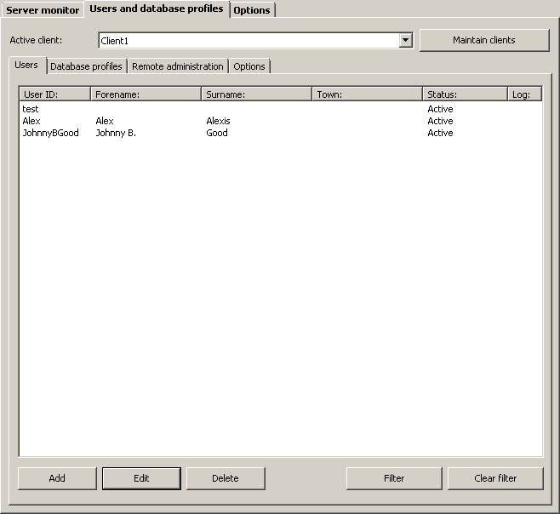
The tab consists of three parts: In the upper margin the selected client is displayed. By clicking the button Maintain clients you can display the dialog for maintaining clients. The biggest part of the dialog contains what has been defined for the client selected: there are sub tabs for maintaining users, database profiles, remote administrators, and client options. All these elements will be explained in detail below.
By default, one client is created when you start the MetaTexis Server for the first time, it is called "Client1". If you are running the Enterprise version you can rename the clients name and add further clients via the button Maintaining clients.

Maintaining clients
When you click the button Maintaining clients the following dialog will be shown:
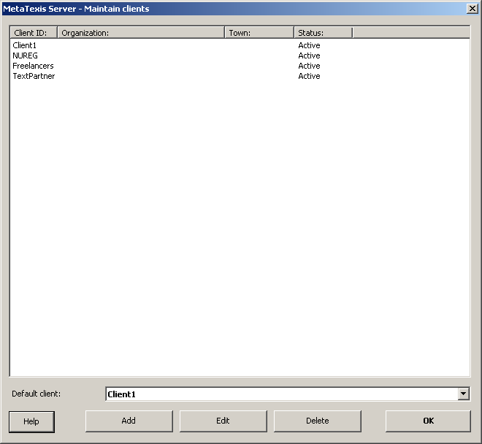
The main element of the dialog is the list of clients. When you have started the MetaTexis Server for the first time, only the default client "Client1" will be displayed. The status of the client (active or not active) is displayed in the column with the same name.
To add a new client, click the Add button (for more details, see the next section).
To display the details of a client, double click an item, or select it and click the Edit button (for more details, see the next section).
To delete a button, click the Delete button. Before the client is actually deleted you will be prompted.
In the drop-down-box Default client you can set the default client. This setting is relevant for imports of user data and database profile data and for requests where no client is specified. In such a case the default client will be assumed by the MetaTexis Server.

Adding or editing a client
When you have clicked the button for adding or editing a client the following dialog will be displayed:
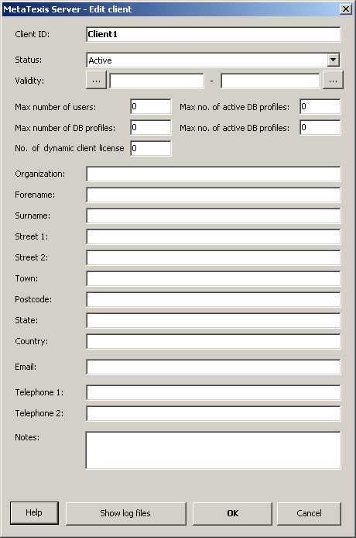
When you add a client, the only mandatory field is the Client ID. All other fields are optional. Click OK to save the data.
The elements of the dialog are explained in detail below:
- Client ID:
This is the only mandatory field. The client ID can be changed at any time, the only restriction being that it must not be identical with another client ID.
- Status:
The status can be "Active" or "Not active". If the status is "Not active", no user and no remote administrator can work with this client anymore.
- Validity:
By setting the validity you can limit the time in which the client is active. Any client requests that are not in the limits of the dates set, will be rejected.
- Max number of users:
The number set here limits the number of users that be created in the given client.
- Max number of active users:
The number set here limits the number of active users in the given client.
- Max no. of DB profiles:
The number set here limits the number of database profiles that can be created in the given client.
- Max no. of active DB profiles:
The number set here limits the number of active database profiles in the given client.
- No. of dynamic licenses:
If the purchased license key included dynamic licenses, this field is editable. It allows you to limit the no. of dynamic licenses per client.
- [Address fields]:
Here you can enter the address details of the client.

Users
In the Users sub-tab the users of a client are maintained. Below you find a sample screenshot:
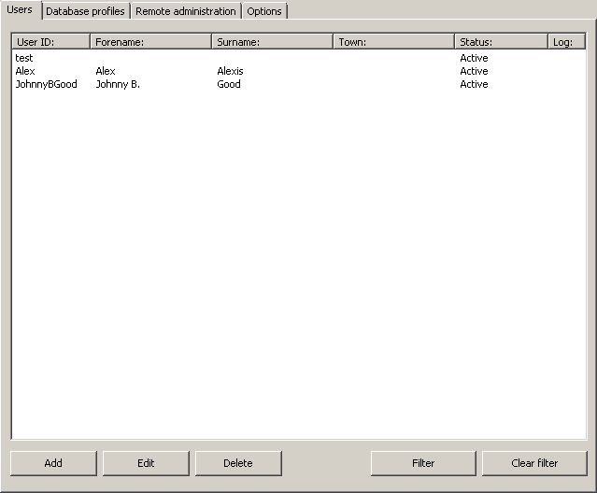
The main element of this tab is the list of users. The status of the user (active or not active) is displayed in the column with the same name. In the Log column you are informed if a log file is being produced for the user.
To add a new user, click the Add button (for more details, see the next section).
To display the details of a user, double click an item, or select it and click the Edit button (for more details, see the next section).
To delete a button, click the Delete button. Before the user is actually deleted you will be prompted.
If the list of users is very long, and you have troubles finding a user, you can use the filter function to limit the number of users shown. For more details, see below.

Adding or editing a user
When you have clicked the button for adding or editing a client the following dialog will be displayed:
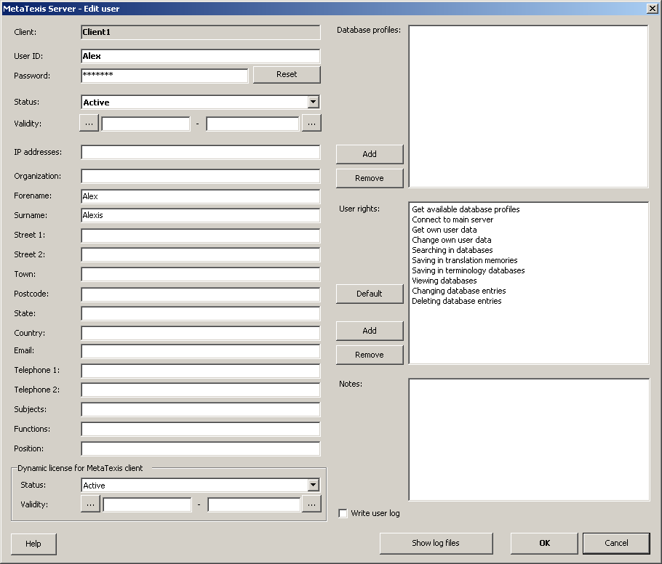
When you add a new user, the only mandatory field is the User ID. All other fields are optional. Click OK to save the data.
The elements of the dialog are explained in detail below:
- User ID:
This is the only mandatory field. The user ID can be changed at any time, with the only restriction that it must not be identical with another user ID in the given client. (Note that you need to inform the user about any change of the user ID, if the user has used the old user ID before.)
- Status:
The status can be "Active" or "Not active". If the status is "Not active", requests by this user will not be processed, anymore.
- Validity:
By setting the validity you can limit the time in which the client is active. Any client requests that are not in the limits of the dates set, will be rejected.
- [Address fields]:
Here you can enter the address details of the user. The user itself can change these data via the client software.
- Dynamic license for MetaTexis client:
If the server license includes dynamic licenses, you can set a dynamic license for a user. To activate a dynamic license, set the status to "Active". To limit the activation temporarily, you can set start and end time by clicking the button next to the related fields.
- Database profiles:
To assign database profiles to the user, click the Add button next to the list of database profiles and select one or more database profiles in the dialog shown. To remove a database profile, select the database profile to remove and click the Remove button.
- User rights:
When you create a new user all available user rights will be assigned. To remove a user rights, select the user right and click the Remove button. To add a user right, click the Add button and select one or more user rights in the dialog shown. To restore the default values, click the Default button.
The follow user rights are available:
- Get available database profiles
- Connect to main server
- Get own user data
- Change own user data
- Searching in databases
- Saving in translation memories
- Saving in terminology databases
- Viewing databases
- Changing database entries
- Deleting database entries
- Notes:
This field allows you to save additional information on the user.
- Write user log:
When this checkbox is active, a user log is created for this user.
- Button Show log files:
When you click this button, any log created for this user will be displayed.

Filtering users
To filter the list of users, click the Filter button. The following dialog will be displayed:
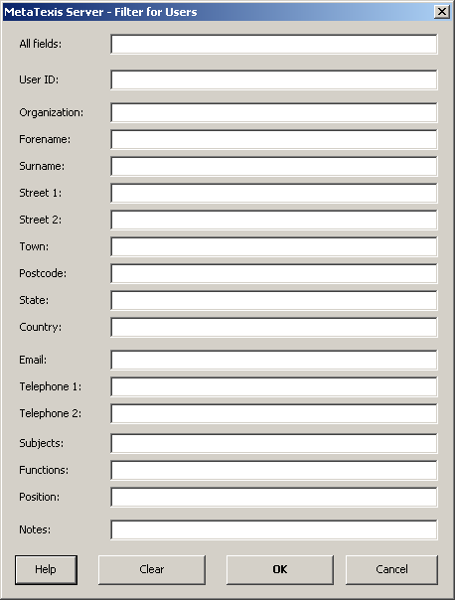
To apply the filter, enter a text string in one of the fields, then click OK. In the list of users only those users will be displayed where all strings entered have been found in the respective fields. (In other words, if you enter strings in more than one field, the individual searches will be connected with the AND operator.) For example, if you enter "John" in the Forename field, and "Good" in the Surname field, only those users will be displayed where the string "John" is part of the forename AND where the string "Good" is part of the surname (e.g. "Johnny B. Good" and "John C. Goodman" would be displayed, whereas "Johnny Handsome" or "William Good" would not).
The All fields field has a special meaning: If you enter a string in the field All fields, all user fields shown will be searched for this string, and all users will be displayed where at least one of the fields contains the string entered.

Database profiles
A database profile is a collection of translation memories and terminology databases assigned to a set of users.
In the sub-tab Database profiles the database profiles of a client are maintained. Here is a sample screenshot:
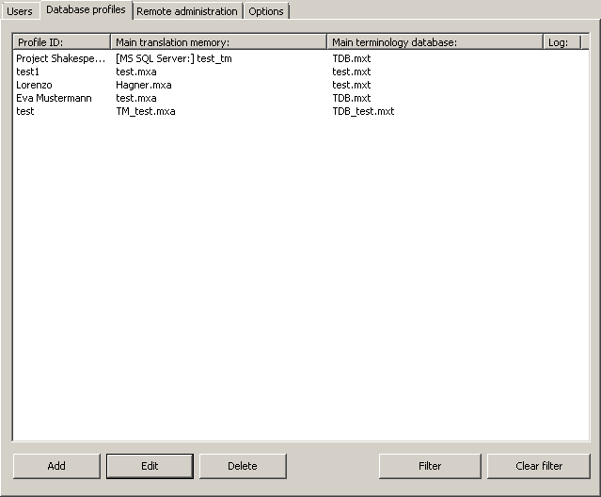
The main element of the dialog is the list of database profiles. The main translation memory and the main terminology database are shown in columns 2 and 3, while the Log column informs you if a log file is being produced.
To add a new database profile, click the Add button (for more details, see the next section).
To display the details of a database profile, double click an item, or select it and click the Edit button (for more details, see the next section).
To delete a database profile, click the Delete button. Before the database profile is actually deleted you will be prompted.
If the list of database profiles is very long, and you have troubles finding a database profile, you can use the filter function to limit the number of database profiles shown. For more details, see below.

Adding or editing a database profile
When you have clicked the button for adding or editing a database profile the following dialog will be displayed:
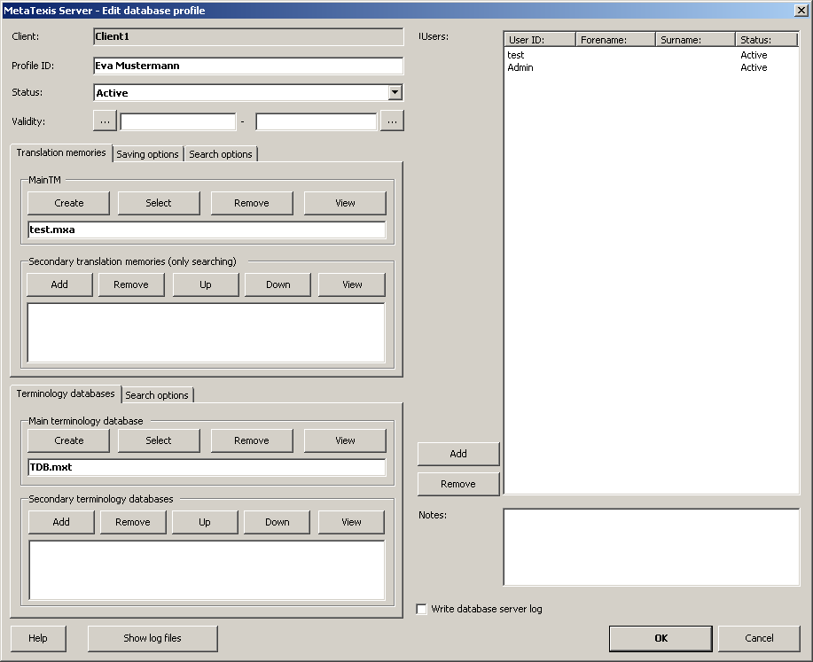
When you create a new database profile, two data must be defined, the profile ID and a TM and/or a TDB. All other settings are optional. Click OK to save the data.
The elements of the dialog are explained in detail below:
- Profile ID:
This is the only mandatory field. The profile ID can be changed at any time, the only restriction being that it must not be identical with another profile ID. (Note that when you have changed a profile ID which was already in use before you need to inform the affected users.)
- Status:
The status can be "Active" or "Not active". If the status is "Not active", no user can work with this database profile.
- Validity:
By setting the validity you can limit the time in which the database profile is active. Any client requests that are not in the limits of the dates set, will be rejected.
- Sub-Tabs for Translation memories:
In the sub-tab Translation memories you can define the main translation memory (which is used for searching and for saving translation units) and the secondary translation memories (that are only used for searching).
The sub-tab Saving options looks as follow:
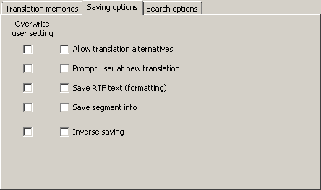
The left column of checkboxes has the title Overwrite user setting. If on of these checkboxes is checked, the related setting next to is taken from the database profile and not from the saving request sent by the user who can set this option also in his client program.
- Allow translation alternatives:
When this checkbox is checked, MetaTexis does not update existing TUs in a TM, but adds another alternative. In most cases, you will probably prefer not to allow translation alternatives.
- Prompt user at new translation
Each time a TU is saved in the main TM, MetaTexis checks whether the source segment is already present in the TM.
Now, let us assume that you want to save a TU in the TM and the source segment of the TU is already present in the TM, but the translation of the TU to be saved is different from the translation present in the TM. If this checkbox is not checked, the translation in the TM will be updated automatically (or a new alternative will be added automatically). But if it is checked, you will be asked whether you want to update the translation (or whether you want to add a new translation alternative).
- Save RTF text (formatting)
When this checkbox is checked, the RTF version of each TU is saved in the TM. The RTF text includes all formatting information for the given TU. Saving the RTF text increases the size of the TM. So, if you do not need the formatting information and/or need to keep the size of the TM small, de-activate this option.
- Save segment info (statistical information)
When this checkbox is checked, the segment info for each segment is saved in the TM. This increases the size of the TM. Therefore, if you do not need this information and/or want to keep the size of the TM small, do not activate this option.
- Inverse saving:
When this checkbox is checked, MetaTexis will save a TU in inverse language direction, if the source text of the TU to be saved if found as translation in the TM. This feature can only be activated when the database has been activated for inverse searching and saving when it was created.
The sub-tab Search options looks as follow:
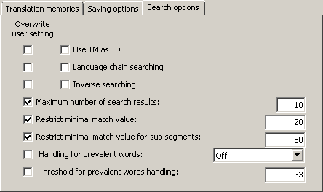
The left column of checkboxes has the title Overwrite user setting. If on of these checkboxes is checked, the related setting next to it is taken from the database profile and not from the search request sent by the user who can set this option also in his client program.
- Use TM as TDB:
When this checkbox is active the TM will also be used as TDB, that is, the TUs in the TM will be treated as terminology. This can increase the number of hits in some cases. However, be careful with this option because it can considerably increase the search time. Especially when the TMs get very big and when CJK languages are affected, it is not recommended to use the option.
- Language chain searching:
If this option is checked, the search will be extended to find more TUs if the TM contains multi-lingual content. For example, let’s assume that you are translating a text from English to French (EN->FR). If the TM contains TUs in the language combinations EN->IT and IT->FR, where one EN segment is very similar or identical to the segment currently searched, the TM search will usually not be successful because there is no EN->FR dataset in the TM. However, if the language chain searching is active, MetaTexis will look further. And if the IT segments are identical, MetaTexis will actually find the French translation of the Italian text and assign it to the English source text, and an EN->FR hit will be displayed. This search even works across TMs!
Moreover, if the inverse searching is active, the language chain search even works if the language direction are mixed, e.g. MetaTexis will find a match if the TM has the TUs IT->EN and FR->IT.
- Inverse searching:
If this option is checked, the TMs will also be searched for matches with the opposite language direction. This option only works if the database is activated for inverse searching and saving when it is created. Combined with the language chain-searching feature, this opens up amazing possibilities (see above).
- Maximum number of search results:
When this setting is active, the maximum number of search results is limited to the number set.
- Restrict minimal match value:
When this setting is active, the minimal match value for fuzzy matches is restricted to the percentage set here. So, even if the user sends a request with a lower percentage, the value set here is used instead of the user setting. This option can be very important to keep search performance high (especially relevant for very big databases and for CJK languages).
- Restrict minimal match value for sub-segments:
When this setting is active, the minimal match value for sub-segment searching is restricted to the percentage set here. So, even if the user sends a request with a lower percentage, the value set here is used instead of the user setting. This option can be very important to keep search performance high (especially relevant for very big databases and for CJK languages).
- Sub-tabs for Terminology databases:
In the tab Terminology databases you can define the main terminology database (which is used for searching and for saving terminology) and the secondary translation memories (that are only used for searching).
The sub-tab Search options looks as follow:
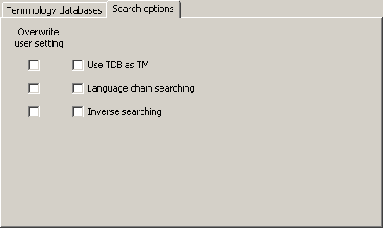
The left column of checkboxes has the title Overwrite user setting. If on of these checkboxes is checked, the related setting next to it is taken from the database profile and not from the search request sent by the user who can set this option in his client program.
- Use TDB as TM:
When this checkbox is active the TDB will also be used as TM, that is, the terms in the TDB will be treated as TUs. This can increase the number of hits in some cases. However, be careful with this option because it can considerably increase the search time. Especially when the TDBs get very big and when CJK languages are affected, it is not recommended to use the option.
- Language chain searching:
If this option is checked, the search will be extended to find more terms if the TDB contains multi-lingual content. For example, let’s assume that you are translating a text from English to French (EN->FR). If the TDB contains terms in the language combinations EN->IT and IT->FR, where one EN segment is very similar or identical to the segment currently searched, the TDB search will usually not be successful because there is no EN->FR dataset in the TDB. However, if the language chain searching is active, MetaTexis will look further. And if the IT segments are identical, MetaTexis will actually find the French translation of the Italian text and assign it to the English source text, and an EN->FR hit will be displayed. This search even works across TMs!
Moreover, if the inverse searching is active, the language chain search even works if the language direction are mixed, e.g. MetaTexis will find a match if the TM has the TUs IT->EN and FR->IT.
- Inverse searching:
If this option is checked, the TDBs will also be searched for matches with the opposite language direction. This option only works if the database is activated for inverse searching and saving when it is created. Combined with the language chain-searching feature this opens up amazing possibilities (see above).
- Users:
To assign users to the database profile, click the Add button next to the list of users and select one or more users in the dialog shown. To remove a user, select the user to remove and click the Remove button.
- Notes:
This field allows you to save additional information on the user.
- Write database server log:
When this checkbox is active, a log is created for this database profile.
- Button Show log files:
When you click this button, any log created for this database profile will be displayed.

Filtering database profiles
To filter the list of database profiles, click the Filter button. The following dialog will be displayed:
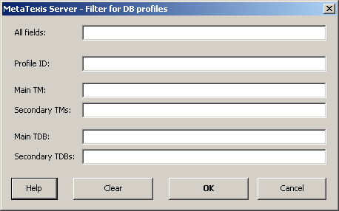
To apply the filter, enter a text string in one of the fields, then click OK. In the list of database profiles only those database profiles will be displayed where all strings entered have been found in the respective fields. (In other words, if you enter strings in more than one field, the single search conditions will be connected with the AND operator.)
The All fields field has a special meaning: If you enter a string in the field All fields, all user fields shown will be searched for this string, and all database profiles will be displayed where at least one of the fields contains the string entered.

Remote administration
In the Remote administration sub-tab you can activate or de-activate remote administration and define the remote administrators. Below you find a sample screenshot:
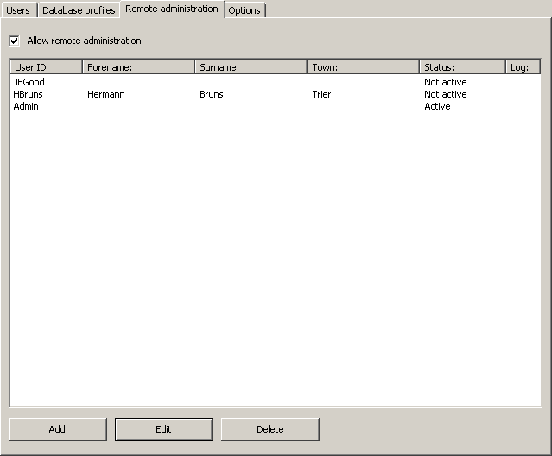
To activate remote administration, tick the checkbox Allow remote administration.
To add or edit a remote administrator, click the Add or Edit button. Virtually the same dialog as for adding new users will be displayed. The only difference is in the user rights. By default, remote administrators have extra user rights that allow them to execute the remote administration.
To delete a remote administrator, click the Delete button. Before the remote administrator is actually deleted, you will be prompted.
The remote administrator can now administer the client from a remote computer with the special program MetaTexis Server Remote Administration. This program is basically identical with the MetaTexis Server, only the special functions for maintaining clients are not available.

Client options
The sub-tab Options contains several settings for clients, all related to creating and selecting TMs and TDBs. They mainly set the options for remote administrators when selecting or creating databases remotely. For a sample screenshot, see here:
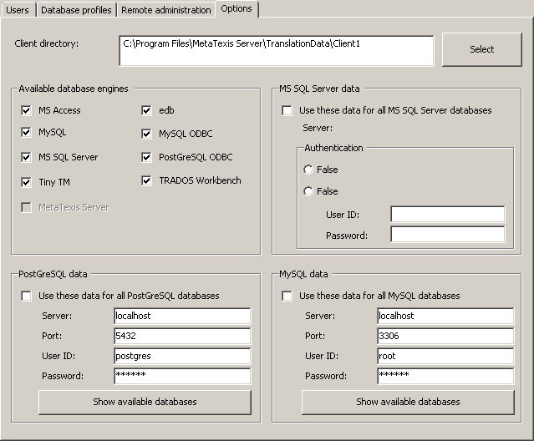
In the following the elements of the sub-tab Options are explained in detail:
The client directory is created automatically when a new client is created. It is supposed to store the databases of the types SQLite, MS Access, edb, and any log files. When remote administrators try to save to create databases, they only have access to the client directory (and to all sub-directories). By clicking the Select button you can change the client directory.
In the frame Available database engines you can define which database engines should be available for creating and selecting TMs and TDBs. Any engine that is not ticked will not be available for creating and selecting databases. This feature is helpful if you have decided that all databases should be handled by MySQL, for example. You would then uncheck all engines except for the MySQL checkbox. (Note: The server programs checks automatically which database engines are available. If a database engine is not available on the server computer it is non enabled and grayed out.)
The frames MS SQL Server data, PostGreSQL data, and MySQL data allow you to set the access data for these database engine centrally so that no administrator is bothered with these settings. If the checkbox Use these settings for all ... databases is active, the administrator will not have to enter these data and can directly enter the name of the database to be created or selected without having to enter or change the engine access data.

Program options
The Options tab contains the settings that steer the behavior of the MetaTexis Server. Here is a typical screenshot:
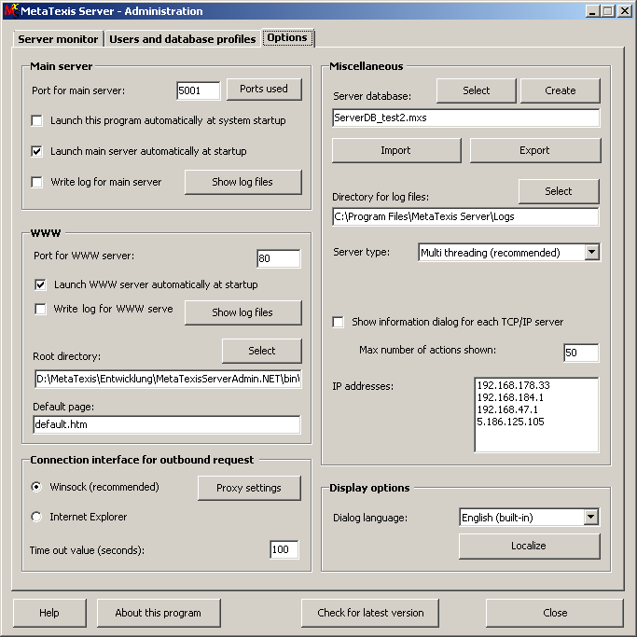
In the frame Main server the following options can be set:
- Port for main server:
The default port for the main server is 5001. Usually this does not interfere with any other application, but if it does you can here set another port.
By clicking the Ports used button you can find out which ports are currently used on the server computer.
- Launch this program automatically at system startup:
When this option is active at system startup, the MetaTexis Server will automatically be started. By default this option is active.
- Launch main server automatically at system startup:
When this option is active, the main server will automatically be launched when the MetaTexis Server is started. By default, this option is active.
- Write log for main server:
When this option is active, a log file will be produced for the main server. When you click the Show log files button the available log files will be displayed.
In the frame WWW the following options can be set:
- Port for WWW server:
The default port for the WWW server is 80. Usually this does not interfere with any other application, but if it does you can here set another port.
By clicking the Ports used button you can find out which ports are currently used on the server computer.
- Launch WWW server automatically at system startup:
If this option is active, the WWW server will automatically be launched when the MetaTexis Server is started. By default, this option is off.
- Write log for WWW server:
When this option is active, a log file will be produced for the WWW server. When you click the Show log files button the available log files will be displayed.
- Root directory:
The root directory for the WWW server contains the HTML files to be displayed by the WWW server. To select another directory, click the Select button.
- Default page:
Here you can define the default page for the WWW server. If the URL contains no file, the default page will be displayed.
In the frame Miscellaneous several important settings can be made:
- Server database:
The server database stores all client data, user data, and database profile data. At the first start of the MetaTexis Server, a default server database will be created, but you can change the server database at any time.
To select another server database, click the Select button.
To create a new server database, click the Create button.
To import users or database profiles into the server database, click the Import button (for more details, see below).
To export users or database profiles, click the Export button (for more details, see below).
- Directory for log files:
The directory specified is used for saving the log files. To define a different log file, click the Select button.
- Server type:
This setting influences the general behavior of the MetaTexis Server, for it steers the way the requests are handled by so-called threads. A thread is a chain of tasks executed by the computer. Two settings can be made:
- Single threading:
When this option is active the MetaTexis Server runs the server processes with fewer threads than in the case of Multi threading. This method should only be used for emergency cases for analyzing purposes.
- Multi threading (recommended):
When this option is active the MetaTexis Server runs each client request in an extra thread. This means that the each user request is handled in parallel with other user request rather than sequentially. So, when a request is received while another time-consuming is already being processed, the new request will nevertheless be started and processed although the older process is still running.
This method should be used to ensure that no client suffers from long processing delays.
- Show information dialog for each TCP/IP server:
When this checkbox is ticked, an information dialog for each TCP/IP server is displayed. Here is a typical screenshots of the information dialogs for the main server:
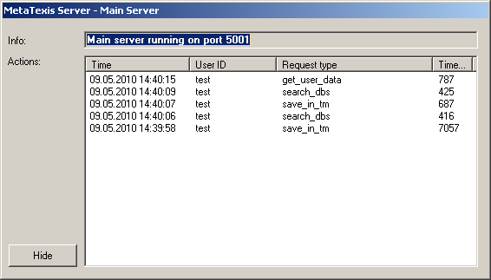
The main server information dialog displays the port used, and in the list of actions the request time, the user ID, the request type, and the time used are displayed in separate columns.
This is a screenshot of the WWW server information dialog:
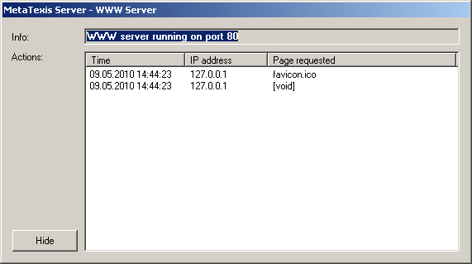
The WWW server information dialog displays the port used, and in the list of actions the request time, the IP address and the page requested are displayed in separate columns.
- IP addresses:
In this listbox the IP addresses of the current system are displayed.
In the frame Display options you can define some user interface parameters:
- Dialog language:
To select another interface language select one language in the drop-down-list Dialog language. There are two built-in languages (English and German). And there will be several additional languages in the future.
By clicking the button Localize you can make your own language version of the MetaTexis Server. For more instructions see chapter "" on page.
The frame Connection interface for outbound requests does not contain any setting for the server itself, but only for special functions, e.g. when you click the button to check for program updates. This frame has the following elements:
- Winsock:
When this option is selected, the build-in Winsock functions of Windows are used to make TCP/IP connections. If you use Winsock for Internet connections, you can set further options via the Options and Proxy buttons. These are explained in detail below. Usually, connections via Winsock are faster. For this reason, this is the default setting. However, in some cases (especially when specific Proxy settings are needed), you might have to select the Internet Explorer.
- Internet Explorer:
When this option is selected, MetaTexis uses the functions provided by the Internet Explorer to make TCP/IP connections.
- Proxy:
If you use Winsock and your computer is connected to a network which does not allow direct Internet connections, but connects to the Internet via a Proxy server, you must enter the proxy data. For example, many LANs of big companies or institutions require a proxy to be defined. To do this, click the Proxy button. The following dialog will be shown:
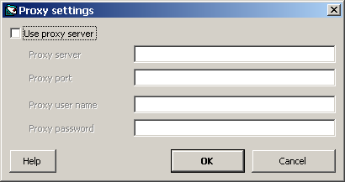
Then, activate Use proxy server checkbox and enter the required data. If you do not know which data to enter, check the proxy settings of the Internet Explorer and copy these data. If this does not work, ask your system administrator or your Internet provider for the required information. (Please note: MetaTexis does not support binary registering.)
- Time out value (seconds):
Here you can set the time out value for outbound connections.

Maintaining TMs and TDBs

TM Policy
Before you decide to actually use one or more TMs for a document you should answer the question whether this makes sense. In general, using TMs makes sense when you think that this will save time and effort. Usually, this tends to be the case when you translate technical documents (in the widest sense) or when you have to translate a revised version of source document. Especially in the latter case you can save an enormous amount of time through using TMs.
However, in some cases it can be better to not use TMs. Especially when you translate novels or poems or other "texts of art", it can be even annoying when you are presented with segments from a TM. For, the similar segments can have completely different meanings in different contexts. On the other hand, even in "texts of art" there can be many repetitions (especially in poems).
The question whether to use a TM or not is connected to the question whether you use the automation options: If you de-activate all automation options, you have full manual control over how the TM is used so that you can avoid the "annoying" effects of using a TM. (For more information about automation policy see "Error: Reference source not found" on page Error: Reference source not found.)
Upshot: As a general rule it is recommended to use a TM, simply because you should not miss any efficiency gains through MetaTexis. However, there might be cases when using TMs can be annoying or superfluous, and you have your preferences, of course. And, you can always change as you go along: You can turn off the automatic functions, and turn them on again later. Unlike other CAT tools, MetaTexis gives you complete flexibility.
If you have decided to work with TMs, you should spend some time on thinking about your TM policy: How many TMs do I want to use? What is the best way to organize them? Where do I want to save them? What do I need my TMs for? What are my personal preferences? Which policy is the most efficient one?
As you can see from these questions, you have many possibilities. In the following I will present and analyze a few possible strategies:
- Some translators prefer to use only one TM for all translations. This TM contains all the translations ever produced by the translator.
Advantages: It is always clear where all TUs are saved. Copying, making backups and transferring the TM to other computers is easy. Most importantly, the leverage effects are best if all TUs are in one TM and are available all the time.
Disadvantages: The database can become very big so that the saving and search processes can get a bit slower. You can lose overview about the contents.
- Another quite extreme strategy is to have one TM per project. Each TM only contains the TUs of one translation project which might consist of one or of many documents.
Advantages: The TMs remain small and the searching and saving processes are very fast. If you want to search in more than one TM, you can simply add other TMs as secondary databases (see below).
Disadvantages: You can lose overview. You have to be careful where to save the TMs: Together with the project documents? In a special directory? With sub-directories?
- Another strategy is to have a TM for each broad subject. For example, all economic documents are saved in the TM for economic texts.
Advantages: The number of TMs remains small while the size of the TMs does not necessarily gets too big.
Disadvantages: Many texts cannot easily be allocated to one single subject. So, in some cases you might have to save a document in two or three subject TMs. You might lose overview.
The first options seems to guarantee the best translation efficiency, for the a TM does not have to be organized! The only purpose of a TM is to provide TUs for re-use, and for this no order is required.
Each approach has advantages and disadvantages. Anyway, you do not have to stick to only one strategy, you can follow all strategies at the same time! And you can always adapt or change your strategy as you go along.
If you change your strategy, some work is required because you have to re-build your TMs. But this task is made easy through the Batch processing command in MetaTexis (see "Error: Reference source not found" on page Error: Reference source not found).

TDB Policy
The first question you have to ask yourself is: Do I need to build a terminology database? This is an important question because building a good TDB can take a lot of time. Before you decide to build a TDB on your own you should make sure that you really need to do it:
- If a dictionary is available on the market which serves your purposes, especially if available on CD-ROM, you do not need to build a TDB. In this case, you can integrate the software in MetaTexis very easily (see "Error: Reference source not found" on page Error: Reference source not found).
- If you need to streamline a translation this can partly be achieved through other functions in MetaTexis: The Search for text function presents you with TUs so that you are able to see how you have translated the text searched in a document or a project (see "Error: Reference source not found" on page Error: Reference source not found). And if you are using TMs you can easily look up words and their translations (see "Displaying TMs" on page 42).
So, in which cases do you need to build a TDB then?
- A TDB is needed when the dictionaries available do not serve your needs, and when it is clear that you will need the information for other projects except the one you are currently working on. For example, if you want to specialize in the field of regional development in the European Union you will want to build an own TDB because there are many special concepts which you will not find in any dictionary.
- A TDB is also needed when the translation of a word or phrase is critical, e.g. when only one translation of a word is accepted by the customer although many are possible. For example, in the field of technical translations many customers provide glossaries which are mandatory. You can import these glossaries in a MetaTexis TDB to work with them conveniently.
- You also need a TDB when different translators are working on a project in parallel. To be able to produce a consistent translations they often need to exchange glossaries/TDBs. Or they need to access one TDB saved at a central location (access via internet, intranet of local area network). (Currently, MetaTexis does not actively support this. Networking support will be available in version 2.)
Besides the question whether to build a TDB at all, you need to find your way in organizing the TDBs. In principle, you have the following possibilities:
- One TDB for all translations, entries are organized by categories:
Advantages: It is always clear where all terminology is saved. Copying, making backups and transferring the TDB to other computers is easy.
Disadvantages: The more entries are added, the more heterogeneous will the TDB get. You lose overview, and the TDB can almost only used by yourself. Especially, in the case of glossaries this approach does not seem to be wise.
- One TDB per translation project:
This approach make sense only when more than one translator works on the project.
Advantages: The TDBs remain relatively small, and searching and saving is very fast. If you want to search in more than one TDB, you can simply add other TDBs as secondary databases.
Disadvantages: You can lose overview. You have to be careful where to save the TDBs: Together with the project documents? In a special directory? With sub-directories?
- One TDB per broad subject:
In many cases, this strategy is the most appropriate one for TDBs.
Compared to TMs, the choice of strategy is more important, for to change the TDB strategy is not as easy as to change the TM strategy. The reason is that TDBs are always "hand-made". Unlike with TMs, the entries are be produced automatically. (To be able to reorganize TDBs the entries have to be made carefully, and categories should be added.)

Main and Secondary Databases
TMs and TDBs are separated in two classes:
- Main TM/TDB
- Secondary TMs/TDBs
The difference between main and secondary databases is not in the databases themselves. Any TM or TDB can be used as the main database for one document and as secondary database for another document (though a database cannot be used as the main database and as a secondary database for one document at the same time, of course). The difference is only in the way the databases are used by the program during the translation process. Secondary databases can only be searched while you translate, whereas main databases are the ones you "work with":
- The main TM is the TM where the TUs of the document are saved in automatically or manually through the following menu commands:
- Save current translation unit in main TM
- Save all translated segments in main TM
- The main TDB is the TDB where new terminology is saved when you add new terminology through the following menu commands:
- Add new terminology pair to main TDB
- Pre-save selection as source text
- Pre-save selection as translation
When a database search is executed, the databases are searched in the following order:
- Main TM/TDB
- Secondary TMs/TDBs (in the order shown in the Secondary translation memories/Secondary terminology databases frame).
The search results are presented in the same order.

Defining Main TM and Main TDB
To select an existing TM/TDB:
- In the Main translation memory/Main terminology database frame, click on the Select button.
- In the dialog box shown select a database type (see Error: Reference source not found).
- If you have selected the local database type, another dialog box will be shown. Select a TM/TDB, as appropriate.
To create a new TM/TDB:
- In the Main translation memory/Main terminology database frame, click on the Create button.
- In the dialog box shown select a database type (see Error: Reference source not found).
- In the following dialog box select a directory and define a name for the new TM/TDB.
To remove a main TM/TDB:
- In the frame Main translation memory/Main terminology database, click on the Remove button.
To view the main TM/TDB:
- In the Main translation memory/Main terminology database frame, click the View button.

Defining Secondary TMs and TDBs
To add a TM/TDB to the list of secondary TMs/TDBs:
- In the frame Secondary translation memories/Secondary terminology databases Click on the Add button.
- In the dialog box shown select a database type (see Error: Reference source not found).
- If you have selected the local database type, another dialog box will be shown. Select a TM or TDB, as appropriate.
To remove a TM/TDB from the list of secondary TMs/TDBs:
- In the Secondary translation memories/Secondary terminology databases frame, click on the Remove button.
To move a TM/TDB up or down in the list of secondary TMs/TDBs:
- In the Secondary translation memories/Secondary terminology databases frame, click on the Up/Down button.
To view the secondary TM/TDB:
- In the Secondary translation memories/Secondary terminology databases frame, click the View button.

Displaying TMs
In MetaTexis all translation memories can be displayed and edited. You have access to many kinds of information and can filter the TM. And, you can navigate through the whole database.

Database Center for TMs
The elements and functions of the database center for TMs are explained in the following paragraphs:
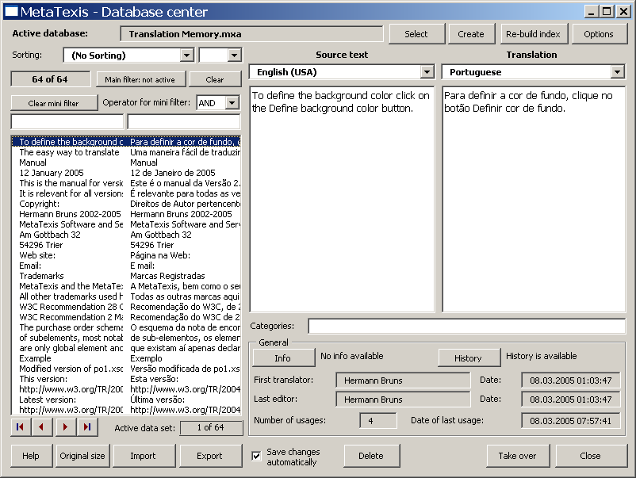
- The name of the active database is shown in a gray text box right below the title bar of the dialog box. (If, for some reason, no database is selected, this is indicated in red.)
Right next to it, near the upper right hand corner there are the two buttons: Select and Create. These buttons allow you to change the TM being displayed. In fact you can display any TM by selecting a database from the dialog box shown and clicking on the Select button. By clicking on the Create button you can create and display new databases.
- The left side of the dialog box contains all you need for sorting, filtering, and navigating through the TM being displayed.
- Sorting:
You can sort the TUs in several ways. To change the sorting rule, select another item from the Sorting drop-down-list.
Moreover, you can choose between ascending and descending order in the drop-down-box located at its side.
- Main filter:
The main filter is a tool for database experts who are familiar with Microsoft Access (though the technique is easy to learn).
To activate the main filter, click on the Main filter: not active button. The following dialog box will appear:
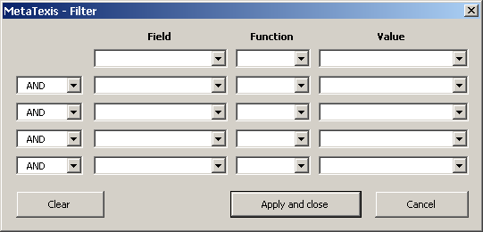
To filter the database select a field in the first line. Select a function and enter the value by which you want to filter the datasets. You can combine several filters in the five lines available. To apply the filter settings, click on the Apply and close button.
When you have activated the main filter, the Main filter: not active button will change to Main filter: active.
To clear the main filter and display all datasets of the TM, click on the button Clear button.
- Mini filter:
The mini filter is very easy to use. You simply have to add a text in one or both text boxes below the Clear mini filter button.
When you enter a text in the left text box (while the right text box is empty) and press the tabulator key or Return on the keyboard, only those TUs which contain the text entered in the source segment are shown.
When you enter a text in the right text box (while the left text box is empty) and press the tabulator key or Return on the keyboard, only those TUs in the translation which contain the text entered are shown.
When you enter text both in the left and the right text box, the result depends on the setting Operator for mini filter. If the operater is set to “AND”, then only those TUs will be displayed where the source text contains the text in the left box AND the translation contains the translation in the right box. If the operater is set to “OR”, then only those TUs will be displayed where the source text contains the text in the left box OR the translation contains the translation in the right box.
To clear the mini filter click on the Clear mini filter button.
- List box with datasets:
The main element of the left side of the dialog box is the list box containing the TUs. Each line represents a TU. The left column contains the beginnings of the source segments, the right column contains the beginnings of the translations.
To navigate in the TM, click on one item in the list box and go up or down in the list by means of the Up, Down, Page Up, Page Down, Home, and End keys. Alternatively you can use the navigating buttons located on the left side below the list box.
The gray box on the right side of the navigation buttons, below the list box, tells which dataset is currently selected.
- In the right side of the dialog box the TU selected including all its details is displayed. The source language and the source text are shown on the left side, the translation language and the translation are shown on the right side.
The categories are shown below.
In the lower part information about the TU selected is shown:
- If a segment info is available, you can click on the button Info button to display the Segment info (see "Error: Reference source not found" on page Error: Reference source not found). (The segment info information is actually saved in the database. So you have the same information as in the document the TU was a part of at saving time.)
- If a saving history is available, you can click on the History button to display the dataset's saving history. The following dialog box will be displayed:
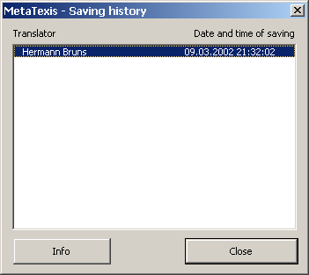
The Saving history dialog box displays the saving history of the current TU, that is, the history of new translations saved in the TM.
If you click on the Info button or if you double click on an entry, the following dialog box with detailed information about the translator and the dialog box is shown:
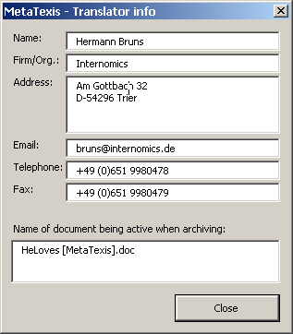
- First translator (who saved the TU first) and Last editor (who saved the last version of this TU) and the corresponding dates:
This is in fact a part of the saving history.
- Number of usages: number of times when the TU was retrieved from the TM to be presented to a translator
- Date of last usages: Date of last time when the TU was retrieved from the TM and presented to a translator.
- At the lower margin of the dialog box there are several buttons:
- Import/Export: see chapter "Importing and Exporting TMs and TDBs" on page 51.
- Delete: When you click on the Delete button, the selected TU will be deleted (after you have confirmed deleting).
- Take over: When you click on the Take over button the translation of the dataset selected is taken over into the document (but only if the cursor is placed in the translation box of an open TU).
- Close: To close the Database center dialog box click on the Close button.

Displaying TDBs
In MetaTexis the TDBs can also be displayed and edited.

Database Center for TDBs
The dialog box is very similar to the dialog box used to display TMs.
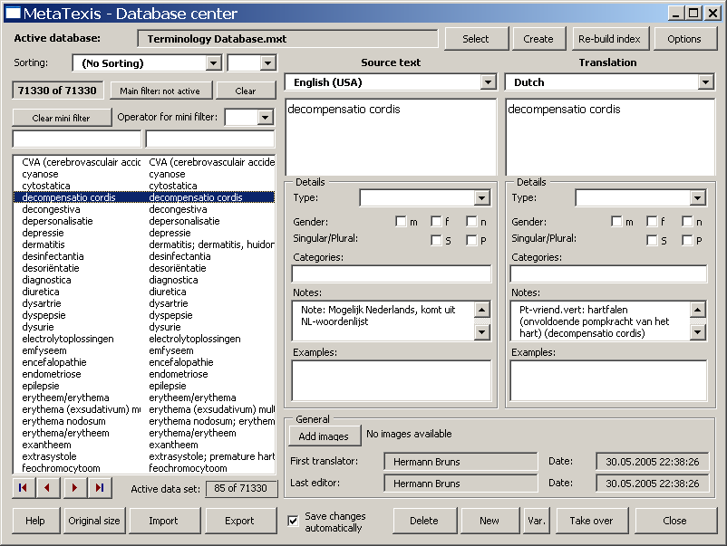
The following paragraphs will only explain those elements which are different from the dialog box used to display TMs (see "Database Center for TMs" on page 42):
- The upper and the left sides of this dialog box are equal to the ones for the TMs Database center dialog box.
- In the right side of the dialog box are displayed the details of the terminology pair which is selected in the list box on the left side. The source language and the source text are shown on the left side, while the translation language and the translation are shown on the right side.
The Detail frame contains details about the source text and the translation:
- Type:
Grammatical type: noun, verb, adjective, adverb, phrase, article, pronoun, preposition.
"Phrase" is not a grammatical type. Select this type in the case of those texts that cannot be characterized by the other types.
The last three types will probably not be used very often (if at all). They are included in the types list mainly for the sake of completeness.
- Gender:
Three check boxes for the gender: male, female and neuter. In many languages this only applies to nouns, in some others it also applies to adjectives, etc.
- Singular/Plural:
Two check boxes for singular and plural. In many languages this only applies to nouns, in some others it also applies to adjectives, etc.
- Categories:
In this text box you can add categories. If you add more than one category, they have to be separated by a semicolon.
- Notes:
In this text box you can add any notes.
- Examples:
In this text box you can add examples of how the terminology is used in sentences or longer phrases.
Note: The Categories, Notes, and Examples text boxes are relatively small. If you double click on them, another dialog box with a much bigger text box will appear. You can view and edit the text displayed. To save any changes click on OK.
In the lower right side general information about the selected terminology pair is shown. The difference with the database center for TMs is that there is no Info button and no History button, but just one View Images button (if any image is assigned to the terminology pair) or Add images (if no image is assigned to the terminology pair). If you click on the Add images button, the Add images dialog box will appear (see "Add Images" on page 49). If you click on the View images button, the View images dialog box will appear (see "View Images" on page 51).
- There are several buttons at the lower margin of the Database center dialog box:
- Import/Export: See "Importing and Exporting TMs and TDBs" on page 51.
- Save changes automatically:
If this box is checked, all changes made are automatically saved in the TDB. If this box is not checked, you will be asked whether you want to save any changes made.
- Delete: When you click on the Delete button, the TU selected will be deleted after you have confirmed this.
- New: When you click on the New button, the Add terminology dialog box will be shown (see "Error: Reference source not found" on page Error: Reference source not found).
- Var.: When you click on the Var. button, the Add terminology dialog box will be shown (see "Error: Reference source not found" on page Error: Reference source not found). The source text and all its details are taken over from the current terminology pair displayed.
- Take over: When you click on the Take over button the translation of the dataset selected is taken over into the document (but only if the cursor is placed in the translation box of an open TU).
- Close: To close the Database center dialog box click on the Close button.

Add Images
Very often words and their translations can only be properly understood when images are available which help to explain the associated terminology (especially in the case of scientific or engineering terminology). In the Add images dialog box you can add images to a terminology pair. If the TDB (terminology data base) contains no images, the Add images dialog box look like this:
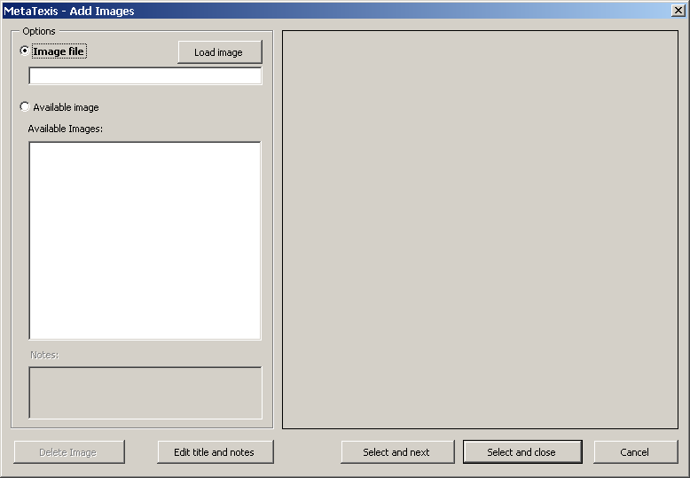
The image to be added is shown on the right side (if an image has already been selected or loaded).
In the Options frame, you can select an image on the left side of the dialog box. You can either load an image file or select an image from the list of available images.
Note: The images are not stored together with the terminology pairs, but separately. (The images are only assigned to the terminology pairs. The reason is that in many cases one image is assigned to more than one terminology pair. To keep the TDB small, the image is stored in the TDB only once.)
To load an image file:
- Click on the Load image button.
- Select an image file in the dialog box shown.
To select an image from the list of images available in the TDB:
- Select an image in the list box Available images.
By default, the file name is taken as the image title. However, you can edit the title and add notes.
To edit the title and notes:
- Click on the Edit title and notes button. The following dialog box will be shown:
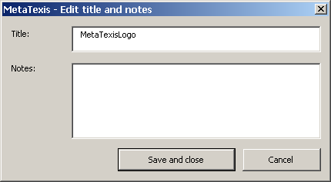
- Edit the title and the notes.
- To save the settings click on the Save and close button.
To add an image to the active terminology pair:
- Load an image file or select an image file in the list of available images (see above).
- If you want to add more images click on the Select and next button.
OR
If you don't want to add any more images click on the Select and close button.

View Images
In the View images dialog box you can view the images assigned to a terminology pair, and you can add or delete images:
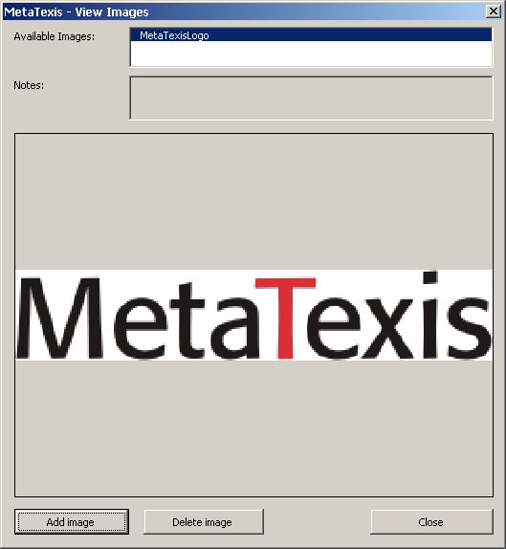
To view an image, click on an image in the list of available images (by default the first item is selected).
To add more images, click on the Add images button. The Add images dialog box will be shown (see above).
To delete an image, click on the Remove image button. (In fact, no image is deleted through this command. Only the assignment is deleted.)

Importing and Exporting TMs and TDBs
Importing data is an important issue. As there are many different CAT tools, the data of TMs and TDBs need to be exchangeable. For example, if you do not only use MetaTexis, but also other CAT tools (because each has special advantages), you will want to be able to import the TMs of the other CAT tools into MetaTexis, and you need to be able to export MetaTexis TMs and TDBs because so far no other CAT tool other than MetaTexis can read the native MetaTexis database format.
MetaTexis provides import and export filters for the most common and most important data formats:
- TMX:
The Translation Memory eXchange format is an open format for exchanging translation memories. It has become the standard exchange format for translation memories.
- Text files for data exchange:
The text format is the most widely used database exchange format. It is supported by virtually every database application. In this format one paragraph is interpreted as one dataset, and the dataset fields are separated by a special character (most commonly a comma or a semicolon). In MetaTexis you can import any text file, be it in ASCII or Unicode.
- Microsoft Access:
Microsoft Access is one of the most widely used database programs.
- Native TRADOS (import only):
TRADOS is one of the most widely used CAT tools. MetaTexis can import native TRADOS database files.
- Native Wordfast (import only):
Wordfast has become a popular CAT tool for Microsoft Word. MetaTexis can import native Wordfast database files.
- MetaTexis (import only):
To be able to consolidate TMs or TDBs you can import other MetaTexis files.

Importing TMX, TRADOS, Wordfast, or MetaTexis files
If you have selected a TMX, TRADOS or Wordfast file to import it into a MetaTexis database, the Importing file dialog box is shown:
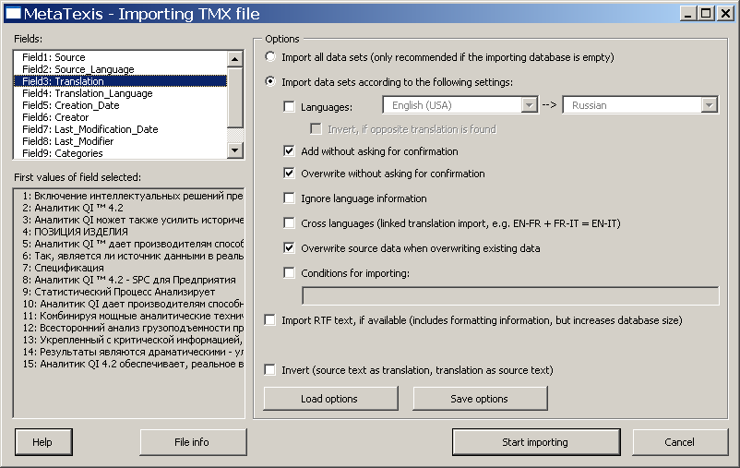
The dialog box has the following elements:
- The fields of the file to be imported are displayed in the Fields box.
- The gray box First values of field selected shows the values of the field selected for the first 20 TUs of the file to be imported.
- When you click on the File info button, a message box will be shown giving you detailed information about the file selected (in case of TMX and Wordfast the information is mainly taken from the header section of the file to be imported).
- In the Options frame you can choose several options which steer the importing process:
- Import all data sets:
If this check box is checked, all data sets are imported.
- Import data sets according to the following settings:
If this check box is checked, the data sets are imported according to the following settings.
- Languages:
If this check box is checked and both languages are defined, only the datasets with these languages are imported.
- Invert, if opposite translation is found:
If this check box is checked, any datasets with the opposite translation direction are inverted. Please check that this makes sense.
- Overwrite without asking for confirmation:
If this check box is checked, when MetaTexis finds that the source text of a dataset to be imported is already present in the database, you will not be asked for confirmation. The old translation will be overwritten.
- Add without asking for confirmation:
If this check box is checked, you will not be asked for confirmation when MetaTexis finds out that the source text of a dataset to be imported is already present in the database. The new translation will be added to the database in a new dataset.
- Ignore language information:
If this check box is checked, the language information will be ignored when MetaTexis checks whether the source text of a dataset to be imported is already present in the database.
- Cross languages:
This check box allows you to create new databases with different language combinations out of two different ones. For example, if you have two databases with the language combinations EN->FR and FR->IT, you can produce a database with the language combination EN-IT by importing the second into the first. In this example the segments/terms in langue FR are used to link the EN with the IT segments/terms.
- Overwrite source data when overwriting existing data:
If this check box is checked, the source data will also be overwritten when identical source segments/source terms are found. If this check box is not checked, only the translation will be overwritten. The latter can cause incorrect data especially when you importing terminology. So, usually this check box should be checked.
- Conditions for importing:
If this check box is checked, only those datasets that meet the conditions defined in the text box below will be imported (see "Import/Export Condition Language" on page 68).
- Import RTF-text, if available:
If this check box is checked, any RTF text available is imported. The RTF text includes formatting information. In some cases this can be important to reduce workload (e.g. when the segments include fields or other demanding formatting elements).
- Invert (source text as translation, translation as source text):
If this check box is checked, all data sets are inverted. This setting overrules the other Invert setting (see above). You can use this options to invert a complete database. Please note: Before you invert a database, check if this makes sense.
To start importing, click on the Start importing button. A message box will be shown informing you about the progress of the importing process. When the database is empty the import process will be very fast in the beginning and get slower and slower as importing proceeds. Importing very big databases (more than 10,000 datasets) can take up to one hour or more (depending on your computer speed). The reason for the decrease of the importing speed is that MetaTexis searches the whole database to check for identical source segments and translations. Moreover, an internal index is produced right at importing time to allow the user to use the database immediately after the importing process has been finished.
You can stop the importing process at any time by pressing Esc on the keyboard.

Importing Text Files, Step 1
The import function for text files has two steps. If you have selected a text file to import it into a MetaTexis database, first the Data import 1 dialog box is shown:
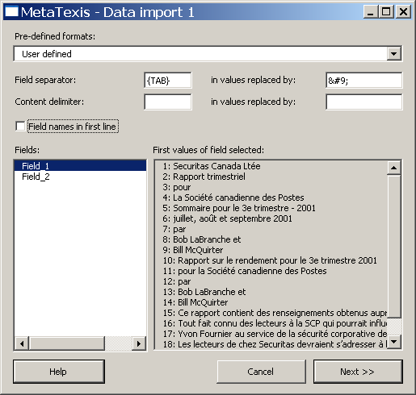
In this dialog box you have to define the field separator and the content delimiter of the text file to be imported.
You can choose between several pre-defined formats in the drop-down-list Pre-defined formats. It lists the most common formats. However, you can also define any other combination of field separator and content delimiter by entering characters in the relevant text boxes.
If the first paragraph of the text file to be imported contains the field names, it is recommended to activate the Field names in first line check box.
The Fields list box lists the fields identified. The First values of field selected list box lists the first 20 values of a selected field. Both lists are updated automatically when you change the settings for the field separator, the content delimiter, or the field names in the first line.
When you have entered the correct settings, click on the Next >> button to go to step 2 of the text file import (see next section).

Importing Text or Access Files, Step 2
When you have defined the text file format or selected an Access file, the Data import 2 dialog box will be shown:
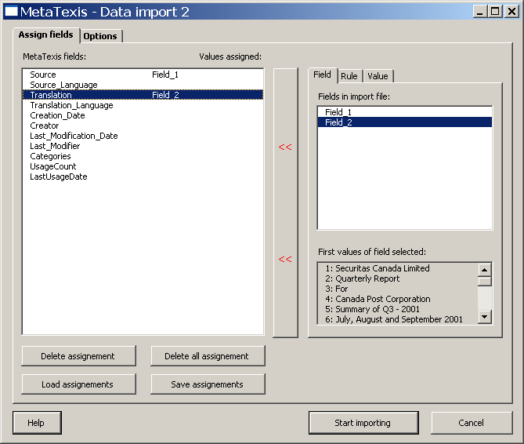
This dialog box consists of two tabs:
- In the Assign fields tab you can assign fields, rules, or values to a field in the MetaTexis database (see below)
- In the Options tab you can define conditions for importing datasets, and you can steer the behavior of MetaTexis during the import process (see "Options" on page 59).
The left part of the Assign fields tab contains a list of the fields in the MetaTexis database and the fields, rules, or values which are assigned to them.
The buttons located in the lower left part of the dialog box have the following functions:
- Delete assignment:
Deletes the assignment of the field selected.
- Delete all assignment:
Deletes all assignments.
- Load assignments:
Loads those assignments which were saved by clicking on the Save assignments button.
- Save assignments:
Saves the current assignments.
In the right part of the dialog box the assignment of the selected field is shown in a multi page element:
- If a field is assigned, the Field tab is active (default). The field assigned is selected in the Available fields list box.
- If a rule is assigned, the Rule tab is active.
- If a value is assigned, the Value tab is active.
To assign a field:
- In the left part of the dialog box click on the field you want to assign a field to.
- Click on the Field tab in the right part of the dialog box
- Select a field in the Available fields list box. (In the First values of field selected list box the first 20 values of the field selected are displayed for information.)
- Click on the << button, in the middle of the dialog box. The field selected will be displayed in the right column of the list of MetaTexis fields.
To assign a rule:
- In the left part of the dialog box click on the field you want to assign a rule to.
- Click on the Rule tab in the right part of the dialog box
- Define a condition in the If text box. For more information about how to define a rule see "Import/Export Condition Language" on page 68.
- Define a value in the Then write text box (or drop-down box). The type and content of this box varies according to the type of the MetaTexis field selected. For example, if you have selected a language field, a drop-down-box with all languages is shown.
- Click on the << button, in the middle of the dialog box. In the right column of the list of MetaTexis fields the text "Rule" will be displayed to indicate that a rule has been assigned to this MetaTexis field.
To assign a value:
- In the left part of the dialog box click on the field you want to assign a value to.
- Click on the Value tab in the right part of the dialog box
- Define a value in the text box (or drop-down box) displayed. The type and the content of this box vary according to the type of the MetaTexis field selected. For example, if you have selected a language field, a drop-down-box with all the languages is shown.
- Click on the << button, in the middle of the dialog box. In the right column of the list of MetaTexis fields the text "Value" will be displayed to indicate that a value has been assigned to this MetaTexis field.
To start importing the file, click on the Start importing button. A message box will be shown informing you about the progress of the importing process. At the beginning when the database is empty the importing process will be very fast, and it will get slower and slower as the importing proceeds. Importing very big databases (more than 10,000 datasets) can take up to one hour or more (depending upon computer speed). The reason for the decrease of the importing speed is that MetaTexis searches the whole database to check for identical source segments and translations. Moreover, an internal index is produced right at importing time to allow the user to use the database immediately after the import process has been finished.
You can stop the importing process at any time by pressing Esc on the keyboard.

Importing Access Files, Step 1
The import function for Access files has two steps. If you have selected an Access file to import it into a MetaTexis database, the Importing Access file dialog box is shown:
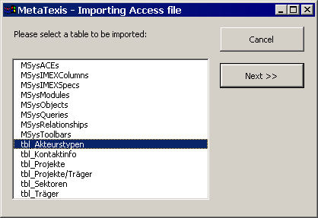
Here you only have to select the table to be imported.
Then click on the Next >> button to go to step 2 of the Access file import (see "Importing Text or Access Files, Step 2" on page 56 above).

Options
The Import dialog boxes include an Options frame or tab where you can define conditions for importing datasets, and you can influence the behavior of MetaTexis during importing time:
- Conditions for importing:
If this check box is checked, only those datasets that meet the conditions defined in the text box below will be imported (see "Import/Export Condition Language" on page 68).
- Overwrite without asking for confirmation:
If this check box is checked, when MetaTexis finds that the source text of a dataset to be imported is already present in the database, you will not be asked for confirmation. The old translation will be overwritten.
- Add without asking for confirmation:
If this check box is checked, you will not be asked for confirmation when MetaTexis finds out that the source text of a dataset to be imported is already present in the database. The new translation will be added to the database in a new dataset.
- Ignore language information:
If this check box is checked, the language information will be ignored when MetaTexis checks whether the source text of a dataset to be imported is already present in the database.
The two command buttons at the bottom have the following functions:
- Load options:
Loads the settings that were saved by clicking on the Save options button.
- Save options:
Saves the current settings.

Database Export Dialog Box
When you have clicked on the Export button in the Import/export dialog box or in the Database center dialog box, the Database export dialog box will be presented to you:
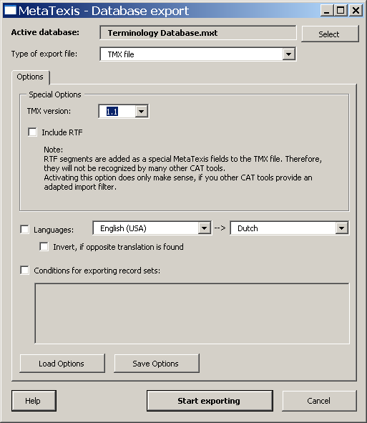
The upper part of this dialog box shows the active database to be exported. You can select another database by clicking on the Select button.
The type of export file can be defined by selecting a type in the Type of export file drop-down-box (default: TMX file).
The main element of the dialog box is a multi-page element with two tabs:
- Options:
The Options tab consists of three parts.
The options in the upper part of the tab change according to the export type selected:
- TMX file:
If TMX file is selected as type of export file, the following options are visible:
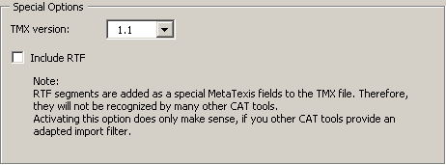
In the drop down box TMX version you can select the TMX version. Two versions are available: 1.1, and 1.4. The most CAT tools are able to import version 1.1. If you select 1.4, make sure that the target program can import this format.
If Include RTF is active, any RTF text is also be included in the TMX file. However, currently this field is not supported by other CAT tools. Check this check box only when you are sure that another CAT tool is able to import this field.
- Text file:
If Text file is selected as type of export file, the following options are visible:
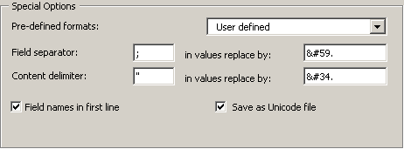
For the Text file type you can define the field separator and the content delimiter. In this format each paragraph contains one data set, and the fields are separated through a field separator. Moreover, a text delimiter can be defined which has the function of a "bracket" for the values in the field.
To make sure that field separator and text delimiter are recognized correctly they must be replaced by other characters in the field values. You can define these replacements according to the requirement of the program which will import the files. By default, the replacements are automatically produced according to the XML specifications for special characters.
The easiest thing to do is to select one of the pre-defined types contained in the Pre-defined formats drop-down-list.
You can choose to have the field names in the first line of the text file.
By default, text files are saved as Unicode files. In the most cases it is strongly recommended to save in the Unicode format to make sure that all characters are correctly saved and can be read on any Unicode enabled system. (By now, all important operating systems and word processors are Unicode enabled.)
- Access database:
If Access database is selected as type of export file, the following options are visible:
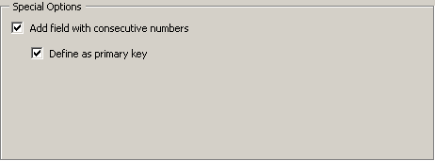
By default, a field with consecutive numbers ("auto increment") is added, and this field is defined as primary key. You can de-activate both options by unchecking the relevant check boxes.
- Languages:
Below the special option you can define languages. If the Languages check box is active, only the TUs with the selected languages will be exported.
Important note: When you want to export TMX files to be imported by other CAT tools than MetaTexis, it is strongly recommend that you activate the Languages check box and define the languages to export. If this is the case, the TMX files produced can also be imported by CAT tools which do not support TMX fully. For example, TRADOS requires the languages to be defined.
If the check box Invert, if opposite language direction is checked, the any TUs with the opposite languages direction will be inverted. Please note: This option is only available for TMX files.
- Conditions:
In the lower part of the dialog you can define conditions for exporting datasets by activating the Conditions for exporting datasets check box (see "Import/Export Condition Language" on page 68).
- Fields:
The Fields tab is only visible for other formats than TMX, and it consists of two list boxes: Available fields and Exported fields plus four buttons in the middle.
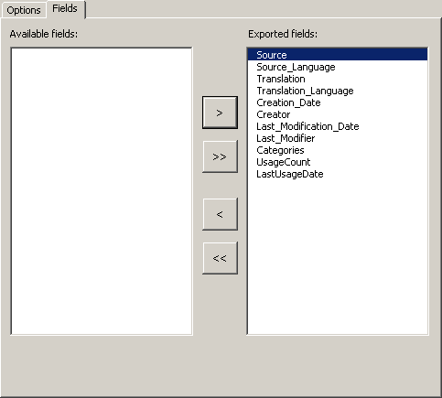
Only those fields which appear in the Exported fields list box are exported. By default all fields are in this list.
You can edit this list by clicking the four buttons in the middle which move the item selected (> and <) or all items (>> and <<).
To start exporting, click on the Start exporting button. A message box informing you about the progress of the exporting process will be shown.
You can stop the exporting process at any time by pressing Esc on the keyboard.
When the exporting process is finished, the Save dialog box is shown. Select a name and click on Save to save the export file.

Compressing TMs and TDBs
When you have worked with the main TM (translation memory) and the main TDB (terminology database) for a long time, these databases can become quite large. Especially when you want to copy a TM or TDB or to store them on media other than hard disks, it is recommended to compress them beforehand.
To compress the main TM, click on the menu command: MetaTexis | Translation memory (TM) | Compress main TM.
To compress the main TDB, click on the menu command: MetaTexis | Terminology database (TDB) | Compress main TDB.

Annex

Connecting a client to the server
To set up a connection from a client program to a MetaTexis Server, the user must first ask the server administrator for the server and logon data. And, of course, the Internet or LAN connection must be available.
To set up a connection to a MetaTexis Server, execute the following steps:
- Execute the appropriate command in the client program to select or create TMs or TDBs (can differe from program to program)
- In the dialog for selecting/creating TMs or TDBs click the Select button. A dialog like the following will be displayed (sample dialog):
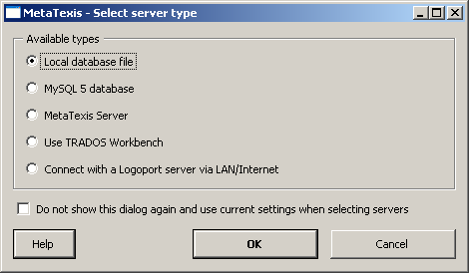
- Select the MetaTexis Server server type and click OK. The following dialog will be displayed:
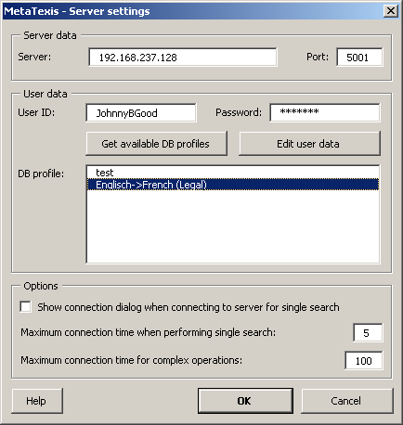
- Enter the server and user data provided to you by the server administrator: server, client, port, user ID, and password.
- Click the Get available DB profiles button to retrieve the available database profiles. If the logon data are entered correctly in step 4, and if a database profile is assigned to the user by the server administrator, the assigned database profiles will be displayed.
- Select a DB profile.
- To save the settings, click OK.
In the Options frame, the following settings can be made:
- Show connection dialog when connecting to server for single search:
When this option is set, the connection dialog is not only shown for complex server requests, but also for relatively simple ones usually requiring only a short amount of processing time. Activate this option if you always need full information about connections via Interne/LAN.
- Maximum connection time when performing single search:
This setting determines the maximum connection time for simple server requests. If your connection to the Internet/LAN is slow, or if the server is very busy, you might have to set a higher value to make sure that you requests are answered.
- Maximum connection time for complex operations:
This setting determines the maximum connection time for complex server requests or for critical requests (e.g. first contact to server).
The Edit user data command button allows you to edit user data if the corresponding right is assigned to the user by the server administrator. For more details, see next section.

Edit user data
The Edit user data dialog allows you to edit your user data:
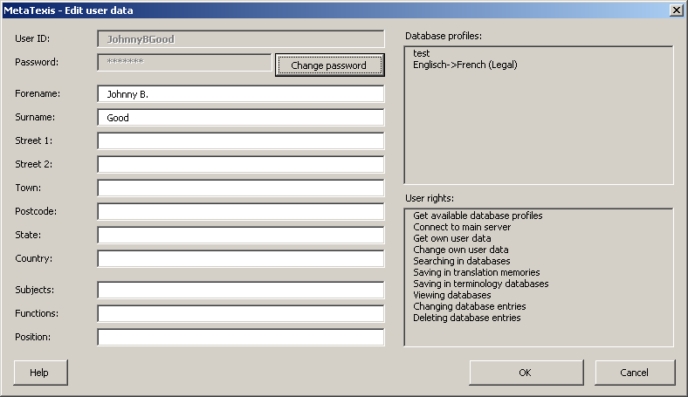
To change the user data, change the data as appropriate and click OK. The data will then be transferred to the MetaTexis Server.
Changeable values have a white background; while values that cannot be changed have a grey background, except for the password. The password can be changed by clicking the Change password button (see next section).

Change Password
The Change password dialog allows you to change your user password:
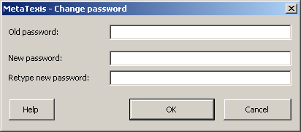
To change your password, first enter the old password, then enter the new password and retype it. Then click OK to save the new password and transfer it to the MetaTexis Server.

Import/Export Condition Language
The import/export functions include a powerful function to select data sets, or field contents. You can define the conditions in a language that is very similar to Visual Basic (less powerful, though).
MetaTexis includes an interpreter which interprets the text of the conditions and decides whether the conditions are met or not.
The result of the conditions that you define must be a truth value, that is they must be either true or false. For example, the result of "3 + 3" is not a truth value, but a number. Therefore, it does not have any meaning as a condition for importing or exporting. MetaTexis will interpret such expressions as "true".
Moreover, a condition must contain a variable. If a condition is always true or always false for any data set or field examined, the condition is meaningless. For example, the expression "3 + 3 = 6" is always true. It does not have any meaning for the import/export process.
The only group of variables are the fields or the datasets to be imported/exported. You cannot define your own variables.
You can refer to a field in several ways:
- Name of the field, as displayed in the list of fields of the dialog box concerned, e.g. "Source".
- "Field" or "Field_" + Number of field, as displayed in the list of fields of the dialog box concerned, e.g. "Field1", "Field_1".
The conditions can be complex, that is, you can combine several conditions with the functions "And" and "Or", and you can use brackets.
Here are some examples for a correct condition:
- Example 1:
Field_1 Incl "John"
- Example 2:
Translation Incl "Johannes"
- Example 3:
Field_1 Incl "John" And Translation Incl "Johannes"
- Example 4:
Field_1 Incl "John" And (Translation Incl "Johannes" or Field3 = "Maria")

Syntax

Variables

Expression | Value
[Name of field] | Value of field named
FieldX | Value of field X
Field_X | Value of field X
FeldX | Value of field X
Feld_X | Value of field X

Constants

Expression | Type | Value
Wahr | Boolean | TRUE
True | Boolean | TRUE
Falsch | Boolean | FALSE
False | Boolean | FALSE

Functions

Expression | VB Function | Notation | Expected Types of Arguments
Und | AND | x And y | x: Boolean, y: Boolean
And | AND | x And y | x: Boolean, y: Boolean
Oder | OR | x Or y | x: Boolean, y: Boolean
Or | OR | x or y | x: Boolean, y: Boolean
Nicht | NOT | Not x | x: Boolean
Not | NOT | Not x | x: Boolean
= | = | x = y | x: Same type
< | < | x < y | Same type
> | > | x > y | Same type
<= | <= | x <= y | Same type
>= | >= | x >= y | Same type
<> | <> | x <> y | Same type
+ | + | x + y | Same type
- | - | x - y | x: Number, y: Number
* | * | x * y | x: Number, y: Number
/ | / | x / y | x: Number, y: Number
\ | \ | x \ y | x: Number, y: Number
^ | ^ | x ^ y | x: Number, y: Number
Enth | Instr | x Enth y | x: String, y: String
Enthält | Instr | x Enthält y | x: String, y: String
Incl | Instr | x Incl y | x: String, y: String
Includes | Instr | x Includes y | x: String, y: String
InStr | Instr | InStr(x, y, z) | x: Long, y: String, z: String
Mid | Mid | Mid(x, y, z) | x: String, y: Long, z: Long
Section | Mid | Section(x, y, z) | x: String, y: Long, z: Long
Abschnitt | Mid | Abschnitt(x, y, z) | x: String, y: Long, z: Long
Right | Right | Right(x, y) | x: String, y: Long
Rechts | Right | Rechts(x, y) | x: String, y: Long
Left | Left | Left(x, y) | x: String, y: Long
Links | Left | Links(x, y) | x: String, y: Long

Punctuation

Character | Type | Function
" | String delimiter
, | Separator | Comma
( | Bracket | Bracket Open
) | Bracket | Bracket Close
{ | Bracket | Bracket Open
} | Bracket | Bracket Close
[ | Bracket | Bracket Open
] | Bracket | Bracket Close

Localization
Every user can make his/her own version of MetaTexis, be it in a completely new language, not shipped with the original version, or be it a variant of an existing language.
There are two built-in languages: US English and German. These cannot be deleted or edited.
All other languages are stored in the "LanguageFiles" sub-directory of the MetaTexis program directory. To be recognized as a language file, a file must be a Unicode or ASCII text file, and it must have the extension ".lng".
(Although the ASCII format can be used, it is strongly recommend to use Unicode to make sure that the language file is correctly interpreted by every computer.)
If a language file with the correct format and the correct extension is copied into the language directory, it will be automatically recognized by MetaTexis (at the next startup of Word), and it will be added to the list of menu languages in the General options dialog box. There is no need to register language files.

Managing Language Files
To access to the localization function open the General options dialog box. On the first tab Miscellaneous there is a Frame called Handling.
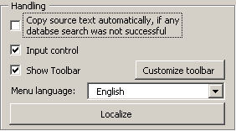
In this frame you can choose the menu language. Besides the built-in English and German languages all language files located in the MetaTexis language directory are listed in the drop-down-box (without their extensions).
To manage the language files click on the Localize command button. The following dialog box will appear:
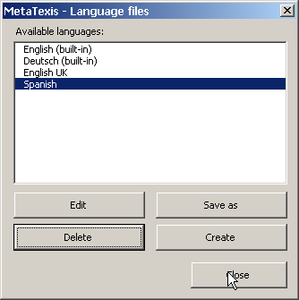
All available languages are displayed In this dialog box: The two built-in languages plus all other language files found. If a built-in language is selected, the Edit and Delete command buttons are disabled, and you can only save them as a language file or create new language files. You can also edit and delete those languages that are not built-in.
- To save the language selected as a language file (including the built-in ones), click on the Save as button. This function is needed if you want to translate a language file on the basis of an existing language, or if you want to make a variant of an existing language.
- To create a new empty language file, click on the Create button. This function is useful if you want to translate MetaTexis using the built-in language file editor.
- To edit the selected language file with the built-in language file editor click on the Edit button (see next section).
- To delete a language file, select it and click on the Delete button. Note that if no copy is present in another place, all information in that language file will be lost.

Edit Language Files
There are two ways to edit a language file: You can either edit a language file by loading it into any text editor (like Microsoft Word), or you can use the built-in language file editor.

Edit Language File in Text Editor
To edit a language file in a text editor you first have to save one of the available languages as a language file by using the Save as button of the Language files dialog box (see last section). Then load this file in a text editor which can load Unicode text files (e.g. Microsoft Word - you can also use MetaTexis, of course.)
The language file has a very simple format: There are only three entities: Header, names of modules, and text elements.
The header consists of the first lines of the file until the first module starts.
The name of a module has this form: "<<NameOfModule>>". You must not change lines with a module name, for they are crucial for recognizing the text elements correctly. The module starts after the module name, and it ends at the next module name or at the end of the file.
The text elements contain the text which is used in MetaTexis. A text element consists of a name and a content which are both in one line, separated through an "=", for example:
"NameOfElement=Text of element"
You must not change the name of the element, including the separator ("="). The only other restriction is that you must not use line breaks in a text element. If you want to add a paragraph in a text element, you have to use a special tag: "{p}". There are no further restrictions.
Lines with an element name not known in MetaTexis and lines without the ("=") separator are ignored.
To edit the language file you simply have to change the text behind the "=".
Remember to save the language file as a Unicode language file, if possible.
Also when you edit a translation file in any text editor, it is recommended to do the final editing in the built-in language file editor of MetaTexis. The built-in editor includes some important functions to check the formal quality of the text elements (see "Formal Quality Checking" on page 75).

Built-in Language File Editor
The built-in language file editor is a simple, but powerful tool for editing language files. When you click on the Edit button in the dialog box Language files the following dialog box will appear:
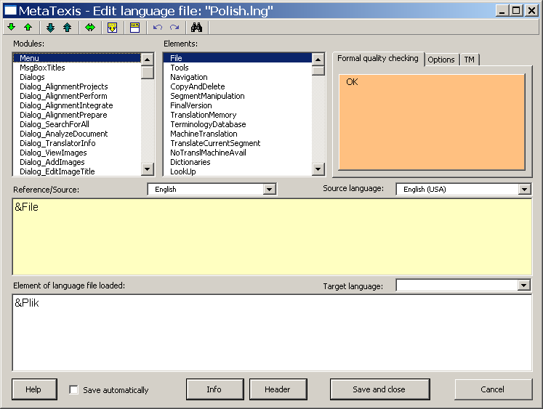
You have access to each text element in MetaTexis through the Modules and Elements list boxes. In the Modules list box you can select the language module, and in the Elements list box you can select the individual text element. The modules names and text elements have no meaning in itself. There could be numbers instead. Nevertheless, they can give you some guidance.
When you choose a text element you are presented with the text element of the reference/source language and the corresponding element of the language file loaded.
Which language is shown in the Reference/Source text box depends on your selection in the Drop-down-box located right above the text box. You can use any language available (except the language loaded for editing). That is, you can also select languages which are not built-in. (If a language file which is used as a reference/source is not complete, the missing text elements are replaced by the built-in English text elements. Therefore, the reference/source text box is never empty. Nevertheless, it is recommended to use a built-in language as the reference.)
The reference/source text cannot be edited.
When you want to edit an element, you can do this in the Element of language file loaded text box. You can only enter pure text; you cannot define any formatting (e.g. italics, bold). However, there are two tags that you have to care about:
- Paragraph tag: {p}
The paragraph tag is replaced by a line break when the text element is displayed to the user. It is used to structure the text element.
- Variable tags: {v1}, {v2}, {v3}, ....
A variable tag is replaced by a value when the text element is displayed to the user. It is most important. You have to be very careful not to miss any.

Formal Quality Checking
The language file editor includes several functions for checking the formal quality of the translation. Each time a text element is accessed or changed, the quality check function is executed. The result is immediately shown in the message box with the orange background which is placed in the upper right part of the dialog box.
Two quality check functions are not optional, because they check critical aspects:
- If the text element of the language file loaded is empty, the message "No text" is displayed.
- If the text element of the language file loaded does not contain the same variables than the reference/source text, the message "Check these Variables" is displayed, and the problematic variables are listed.
All other quality checks are optional, because their importance is less critical and because the results depend partly on the languages used. They are defined in the Options tab:
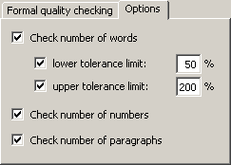
The Options tab contains the following check boxes:
- Check number of words:
If you check this check box, a message is displayed if the text element of the language file edited contains less words than the lower limit or more words than the upper limit compared to the reference/source text. The limits can be defined in the two text boxes: lower tolerance limit and upper tolerance limit.
- Check number of numbers:
If you check this check box, a message is displayed if the number of numbers is different.
- Check number of paragraphs:
If you check this check box, a message is displayed if the number of paragraph tags is different.
If the active text element is correct, from a formal point of view, "OK" is displayed.

Toolbar
The language file editor includes a toolbar that looks similar to the MetaTexis toolbar in Word:
Through this toolbar you have access to some functions that are quite similar to the ones you know from the MetaTexis toolbar in Microsoft Word. The commands are explained in detail below:
- Go to next/previous element /
Shortcuts: Alt+Down / Alt+Up
With these command you can navigate the whole language file.
- Go to next/previous element to be edited /
Shortcuts: Alt+Shift+Down / Alt+Shift+Up
These two commands are most important. They allow you to go to the next element which is not formally correct according to your settings. That is, by this command you can go to the next element that does not pass the quality checking test. For this reason, it is a very helpful function, especially at the end of the editing process.
- Go to last element shown
Shortcut: Alt+Home
With this command you can jump between the last two elements shown.
- Copy source text
Shortcut: Alt+Shift+C
Copies the source text.
- Delete text element in file loaded
Shortcut: Alt+Shift+Delete
Deletes the text element of the file loaded
- Undo/Redo /
Shortcuts: Ctrl+Z / Alt+Shift+Backspace
Normal Undo/Redo commands.
- Search for text
Shortcut: Ctrl+F, Repeat search: Shift+F4 or Ctrl+Shift+F
Search for text in source text and/or loaded text. (For more information see "Error: Reference source not found" on page Error: Reference source not found).

Saving
To save the language file, simply click on the Save and close button. However, in many cases you will want to use the automatic saving function to make sure that you do not lose any work done. If you check the Save automatically check box, located at the lower left part of the dialog box, the language file is saved each time when you go to another text element.

FAQ

General note
If you encounter a problem which is not covered by the FAQ below, report the problem to the MetaTexis support by sending an email to the address support@metatexis.com.
If you are not sure whether you have installed the latest version, please install the latest version of MetaTexis available at www.metatexis.com, or click the button Check for latest version.

Database engines

Error when using MS SQL Server "Named Pipes Provider: Could not open a connection to SQL Server"
To fix this issue you might have to execute all the following four methods (from A to D), but you might also have to execute only method of these.
A. To enabled Named Pipes and TCP/IP protocols on the database server, execute the following steps:
1. Start → All Programs → Microsoft SQL Server 2005 → SQL Server Configuration Manager
2. In the left hand pane, expand "SQL Server Configuration Manager (Local) → SQL Server 2005 Network Configuration"
3. In the left hand pane, highlight "Protocols for SQLEXPRESS"
4. In the right hand pane, right click "Named Pipes" and select "Enable"
5. In the right hand pane, right click "TCP/IP", select "Enable" and then select "Properties"
6. On the "IP Addresses" tab ensure that "Enabled" is set to "Yes" for each network adapter listed.
7. Click [OK] to close the TCP/IP Properties dialog.
8. In the left hand pane select "SQL Server 2005 Services"
9. Right click "SQL Server (SQL EXPRESS)" and select "Restart"
Whilst it is not required for this process, it can make the task of configuring remote access to SQL Server Express easier if you also start the process "SQL Server Browser". You may need to open the properties and on the "Service" tab change the Start Mode from Disabled to Automatic, before you can start the process.

B. Add SQL Server 2005 Express as an exception to the windows firewall. You will need to add SQL Server 2005 Express as an exception to any firewall software that is running locally. The following sequence assumes the Windows XP Firewall:
1. Start → Control Panel (classic view) → Windows Firewall
2. On the Exceptions tab, click "Add Program..."
3. Browse to "sqlserver.exe" and click [OK]. This is normally located in the folder "Program Files\Microsoft SQL Server\MSSQL.1\MSSQL\Binn"
4. Repeat for "sqlbrowser.exe" if you have set the "SQL Server Browser" service to run. This is normally located in the folder "Program Files\Microsoft SQL Server\90\Shared"
5. Click [OK] to close the Windows Firewall dialog.
If you still find that you cannot connect, then try opening TCP Port 1666 in the Windows Firewall:
1. Start → Control Panel (classic view) → Windows Firewall
2. On the Exceptions tab, click "Add Port..."
3. The "Name" can be anything, but I suggest something like "TCP Port 1666 for SQL Server". For the "Port number" enter 1666, and ensure that TCP is selected. Click [OK]
4. Click [OK] to close the Windows Firewall dialog.
For those that are interested, the port number 1666 comes from the "TCP Dynamic Ports" displayed on the "IP Addresses" tab of the "TCP/IP Properties" of the TCP/IP Protocol listed by SQL Server Configuration Manager.
If you get this error when trying to connect using Microsoft SQL Server Management Studio then try opening UDP port 1434.

C. Ensure that the SQL Server 2005 Express server process is running.
Check this by:
1. Start → Control Panel (classic view) → Administrative Tools → Services
2. Scroll down and check that "SQL Server (SQLEXPRESS)" has the status of "Started". Start it if it is not already started.

D. Ensure that the SQL that the built-in account of the local system is used:
1. Start SQL Server Configuration Manager
2. Right-click on the SQL server name that you created
3. Select 'Properties'
4. On the Log On tab, set the option Log on as: to
"Built in account, Local System"
5. Restart Service and close Sql Server Config Mgr

